**OKANOGAN COUNTY**

DRAFT

**OUTDOOR RECREATION PLAN**

**SEPTEMBER 2020OKANOGAN COUNTY**

**OUTDOOR RECREATION PLAN**

**COUNTY COMMISSIONERS**

Jim Detro, Chairman

Andy Hover, Vice Chair

Chris Branch

**Okanogan County**

Stephanie Palmer, Planning Director

Josh Thomson, Public Works

Ted Murray, Planning Recreation

**PATHS AND TRAILS ADVISORY COMMITTEE**

James DeSalvo, Methow Valley Sports Trail Association

Kristin Ackerman, Pacific Northwest Trail Association

Stacy Shutts, Okanogan Land Trust

Justin Haug, Washington Department of Fish and Wildlife

**EXECUTIVE SUMMARY**

The citizens of Okanogan County and those that visit the region place a very high value on outdoor recreation, and have a strong desire for new and/or improved recreational facilities that support the lifestyle and economic sustainability of local residents. Examples of the growth of recreation demand include the Methow Valley Sports Trails Association, which has seen a ten percent annual increase in user days over the past decade. There is a growing demand for ongoing trail additions and improvements in the Okanogan Valley (e.g. the conversion of the old rail bed along the Similkameen River).

Through the planning process, the public identified both specific projects as well as general needs. Specific examples include expansion and on-going maintenance of the existing Methow Valley Trail system and, ongoing improvements in the County’s snowmobile grooming program. General public feedback suggests directing funding toward the projects that can leverage the greatest overall economic benefit to the region, and there is a demand for greater trails and recreation planning and coordination between agencies, businesses and private landowners.

The focus of the plan is outdoor recreation in the unincorporated lands of Okanogan County. The intent is to provide the County with a document that can provide a foundation for working with local organizations, cities, towns, state and federal governments, utilities and others on long range recreation planning, maintenance of existing facilities and development of new facilities that connect and enhance existing and proposed recreational opportunities. It is important to note that the plan does not specifically address all outdoor recreation needs on state and federal lands, but rather focuses on projects that reflect connections with existing and proposed projects that either border or provide linkages to federal, state, local or private recreation opportunities

The Action Plan recommends first, to proceed with those projects and programs already underway or which exist in a detailed form. A high priority is continuation of an enhancement existing outdoor recreation projects, including grooming of snowmobile trails and Nordic ski trails, improvements at Sno-Parks, and continued cooperation on developing both motorized and non-motorized year-round trails in the Methow Valley and north county areas. Existing facilities are valued and used by county residents and visitors. New projects should not detract from the long term sustainability of current facilities and recreational assets.

The second recommendation is that the County Commissioners establish a mechanism for plan implementation and ongoing citizen participation through the Outdoor Recreation Coordinator and advisory body to help with implementation and long term coordination.

The third recommendation is that a detailed inventory of trails, outdoor and indoor recreational facilities, highway ROW opportunities (for improved recreational safety), and potential river and lake access points be conducted.

A fourth piece is recognition and outreaching the important role the County and U.S. Forest Service road systems play in providing both access as well as opportunities for enhancing recreation.

The final piece of the action plan is coordination and cooperation.

TABLE OF CONTENTS

INTRODUCTION 6

OKANOGAN COUNTY YESTERDAY AND TODAY 8

PLANNING AREA 8

DEMOGRAPHICS 8

ECONOMY 13

PARKS AND RECREATION TRENDS 13

PLANNING AND SERVICES AREAS 14

WHAT AREA ARE WE PLANNING FOR? 14

WHAT IS OUR SERVICE AREA? 14

INVENTORY 16

WHAT RECREATIONAL FACILITIES CURRENTLY EXIST 16

WHAT PLANS ARE IN PLACE? 20

PLANNING FOR THE FUTURE 22

GOALS 22

DEMAND/NEED ANALYSIS 26

PATHS AND TRAILS COMMITTEE 26

PUBLIC PARTICIPATION 26

DEMAND/NEEDS SUMMARY 38

ACTION PLAN 39

OUTDOOR RECREATION CAPITAL IMPROVEMENT PLAN 49

FINANCING 56

TABLE OF CONTENTS

(CONTINUED)

TABLES

|  |  |
| --- | --- |
| Table 1 – Community populations……………..……………………...………………… | 9 |
| Table 2 – County Population 1900-2010……………………………….………………. | 9 |
| Table 3 – Racial Breakdown………………………………………………...…………… | 12 |
| Table 4 – Racial Breakdown with Hispanic Origin…………………..………………… | 12 |
| Table 5 – Household Data…………………………………………………..…………… | 13 |
| Table 6 – Intermediate Population Projections………………………………………… | 14 |
| Table 7 – Annual Growth………………………………………………………………… | 14 |

CHARTS

|  |  |
| --- | --- |
| Chart 1 – County Population 1900-2010……………………………………………… | 9 |
| Chart 2 – Okanogan County Age Distribution 2010 Census………………………… | 10 |
| Chart 3 – Washington State Age Distribution 2010 Census………………………… | 11 |

APPENDICES

|  |  |
| --- | --- |
| Appendix A – Parks and Recreation Facilities Inventory |  |
| Appendix B – SCORP 2003 Inventory |  |
| Appendix C – Public Involvement and Process & Survey Results |  |
| Appendix D – Articles, News Releases and Notices |  |
| Appendix E – Trial Usage, Purpose and Development Criteria |  |
| Appendix F – Public Comments |  |
| Appendix G – Recreation Maps |  |
| Appendix H – MVSTA Economic Impact Analysis |  |

## **INTRODUCTION**An outdoor recreation plan is an integral part of and usually included as a portion of the Parks and Recreation Element of a community’s comprehensive planning program. In this case the community is Okanogan County and this document reflects an update of the 2004 Okanogan County Parks and Recreation Element of the County Comprehensive Plan. This Plan, contains an inventory and description of existing public recreation facilities and opportunities, goals and objectives to guide plan implementation, the determination and analysis of recreation needs, and plans for meeting those outdoor recreation needs.This Plan strives to strike a balance between public demands for outdoor recreation activities and facilities and available resources. Population growth, demographic characteristics, safety, historical considerations and proximity to other population centers and major recreation areas were assembled as background information. The most important considerations of this Plan were public desires and funding sources available to the County.In addition to the facilities and opportunities provided by a wide range of public entities in the County, the private sector provides a large array of recreation opportunities. This plan recognizes the important role private individuals and businesses play in promoting, developing and capitalizing on recreation in the County. However, the focus of this document is on facilities and activities that will be developed and maintained by the County and a variety of partners (e.g. trails – year round, motorized and non-motorized).

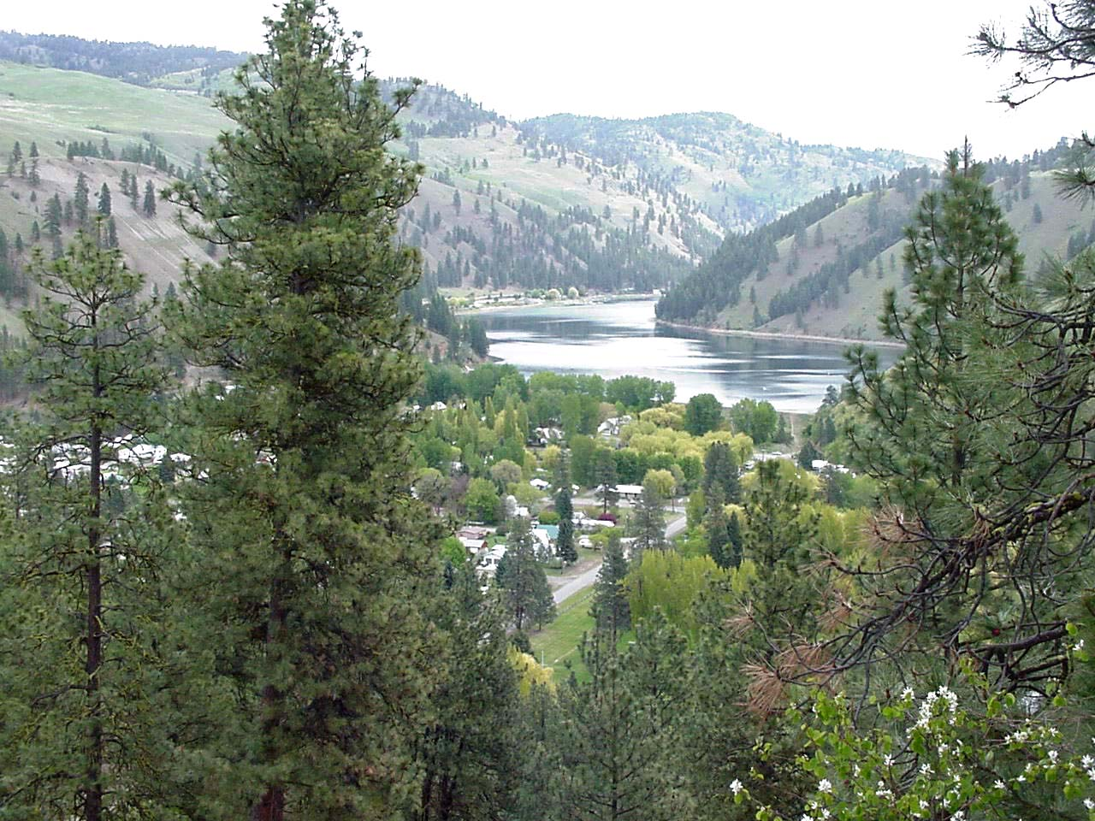

This Plan was created using information gathered by County staff and the Paths and Trails Committee and provided the basis for setting Goals and Objectives, and for the creation of the Action Plan.

Conconully lower reservoirConconully is a hub for motorized recreation with connections to state and federal lands

**The purposes of the Plan are:**

## To develop a comprehensive and prioritized approach for supporting maintenance, development and coordination of public recreation facilities and opportunities in the county. The plan shall provide a basis for decision making and budgeting over the long term.

## To identify public parks and recreation needs and outline an implementation strategy.

## To establish a vision and priorities for: A. Program/project development B. Land acquisition/disposal C. Capital improvements

## COVERTo ensure conformance with federal and state policy requirements for shared revenues and grant assistance.

Trail ride – Okanogan Highlands

## 

## **OKANOGAN COUNTY YESTERDAY AND TODAY**

## **PLANNING AREA**Located in north central Washington, Okanogan is the largest county in Washington State, with over 5,301 square miles. It is located directly north of Chelan and Douglas Counties and extends to the Canadian Border. The western border, shared with Skagit and Whatcom Counties, runs along the Pacific Crest of the Cascades Mountains, which provides a natural barrier to the Pacific weather systems. Ferry County comprises the eastern border. Also, encompassed within the southeastern corner of the county is the Colville Indian Reservation with approximately one-half of the Reservation’s 1.4 million acres lying within Okanogan County.**DEMOGRAPHICS**The population of Okanogan County was 42,730, according to the Office of Financial Management. It is the largest county in land area in the state with 5,267.98 square miles. This comes to just over seven people (7.5) per square mile. Table 1 contains population data for the year 2010 by community and the unincorporated area

## **Table 1 – Community Population**

|  |  |  |  |
| --- | --- | --- | --- |
| Area | Population 2000 | Population 2010 | Population 2019 EST |
| Okanogan | 2,415 | 2,585 | 2,640 |
| Omak | 4,495 | 4,845 | 4,940 |
| Brewster | 2,055 | 2,365 | 2,405 |
| Conconully | 177 | 220 | 235 |
| Coulee Dam - part | 890 | 910 | 915 |
| Elmer City | 310 | 240 | 290 |
| Nespelem | 235 | 235 | 245 |
| Oroville | 1,615 | 1,690 | 1,700 |
| Pateros | 595 | 667 | 585 |
| Riverside | 305 | 280 | 285 |
| Tonasket | 1,025 | 1,025 | 1,110 |
| Twisp | 1,000 | 925 | 980 |
| Winthrop | 375 | 410 | 480 |
| Unincorporated area | 24,072 | 25,803 | 25,920 |

## Historical population totals show the population steadily rising, with one year of decline. A table showing these totals from 1900 - 2010 and a graph illustrating this

## period follows.

## **Table 2 - County Population 1900 - 2010**

|  |  |  |  |
| --- | --- | --- | --- |
| Year | Population | Increase (or Decrease) | Percent Increase(or Decrease) |
| 2010 | 41,120 | 1,556 | 3.78% |
| 2000 | 39,564 | 6,214 | 15.71% |
| 1990 | 33,350 | 2,687 | 8.06% |
| 1980 | 30,663 | 4,796 | 15.64% |
| 1970 | 25,867 | 347 | 1.34% |
| 1960 | 25,520 | -3,611 | -14.15% |
| 1950 | 29,131 | 4,585 | 15.74% |
| 1940 | 24,546 | 6,027 | 24.55% |
| 1930 | 18,519 | 1,425 | 7.69% |
| 1920 | 17,094 | 4,207 | 24.61% |
| 1910 | 12,887 | 8,198 | 63.61% |
| 1900 | 4,689 | *** | *** |

## Source: Washington State 1991 Data Book, Office of Financial Management

## **Chart 1 – County Population 1900 to 2010**

## 

## Source: 2010 U.S. Census

Okanogan County has a median age of 37.2 in 2010, meaning that half of the residents are above the age of 37 and half are below. The following chart compares the ages of Okanogan County residents in 2010 to those of 2000.

## 

**Chart 2 - Okanogan County Age Distribution 2000 & 2010 Census**

Chart 3 - **Washington State Age Distribution 2010 Census**

Washington State has a median age of 37.3.

## **RACIAL BREAKDOWNS**The major ethnic groups of Okanogan County are White, American Indian, and Hispanic. Tables follow illustrating this mix.

Table 3 compares minority totals to State averages. As can be seen, although Okanogan County has very few black, Asian, or Pacific Islander people, the total minorities are much higher than the State total. This is due to the presence of the Colville Indian Reservation, which overlaps about 19 percent of Okanogan County, and many Hispanics who live in the County.

## **Table 3 – Racial Breakdowns**

|  |  |  |  |
| --- | --- | --- | --- |
| Race | County Totals | Population  Percentage | State Percentages |
| White | 30,399 | 73.9% | 74.8% |
| Black | 159 | 0.4% | 3.5% |
| American Indian & AK Native | 4,675 | 11.4% | 1.5% |
| Asian & Pac Is. | 268 | 0.7% | 7.2% |
| Hispanic | 4,163 | 10.1% | 10.2% |
| Two or More | 1,456 | 3.5% | 2.8% |
| Total | 41,120 | 100% | 100% |

## Source: 2010 US Census

Table 4 shows which of these residents claim Hispanic origin. This can be confusing, but it must be remembered that Hispanic origin is an ethnic group, not a racial category.

## **Table 4 – Racial Breakdowns with Hispanic Origins**

|  |  |  |  |  |
| --- | --- | --- | --- | --- |
| Total | 41,120 | 100% | 7,227 | 100.0% |
|  |  |  |  | Hispanic Origin |
| White | 30,399 | 73.9% | 2,307 | 31.9% |
| Black | 159 | 0.4% | 28 | 0.4% |
| Native American | 4,675 | 11.4% | 284 | 3.9% |
| API | 268 | 0.7% | 18 | 0.2% |
| Other Race | 4,163 | 10.1% | 4,121 | 57.0% |
| Two or More | 1,456 | 3.5% | 469 | 6.5% |

## Source: 2010 US Census

## **HOUSEHOLDS**There are 15,027 households in Okanogan County. There are also group facilities such as correctional and juvenile institutions, nursing homes, emergency shelters, and other group quarters where the remaining 2% of the population is housed.

## **Table 5 – Household Data**

|  |  |  |  |  |  |
| --- | --- | --- | --- | --- | --- |
|  |  | Population In  Households | Population In Group  Quarters | Occupied Housing  Units | Average Person Per  Household |
| **1970** | **Households** | **25,536** | **331** | **10,447** | **2.4** |
|  | Unincorporated | 12,240 | 86 | 5,730 | 2.1 |
|  | Incorporated | 13,296 | 245 | 4,717 | 2.8 |
| **1980** | **Households** | **30,406** | **257** | **11,371** | **2.7** |
|  | Unincorporated | 16,423 | 32 | 5,741 | 2.9 |
|  | Incorporated | 13,983 | 225 | 5,630 | 2.5 |
| **1990** | **Households** | **33,350** | **605** | **16,629** | **2.0** |
|  | Unincorporated | 19,294 | 305 | 10,340 | 1.9 |
|  | Incorporated | 14,056 | 325 | 6,289 | 2.2 |
| **2000** | **Households** | **38,713** | **851** | **15,211** | **2.5** |
|  | Unincorporated | 23,285 | 362 | 8,769 | 2.7 |
|  | Incorporated | 15,428 | 489 | 6,258 | 2.5 |
| **2010** | **Households** | **40,480** | **640** | **16,519** | **2.5** |
|  | Unincorporated | 24,517 | 263 | 9,952 | 2.5 |
|  | Incorporated | 15,963 | 377 | 6,567 | 2.4 |

## Source: 2010 US Census, WS-OFM

## **PROJECTIONS**The Office of Financial Management, Forecasting Division, has made high, intermediate, and low population projections for Okanogan County. Table 6 below shows the intermediate projections. In addition, Table 7 shows other population projections, calculated using the average increase of the years 1990 to 2010 of 1.863% per year.

|  |  |
| --- | --- |
| **Table 6 – Intermediate Population Projection** | **Table 7 – 1.86% Annual Growth** |
| |  |  | | --- | --- | | 2010 | 42,739 | | 2015 | 44,923 | | 2020 | 46,526 | | 2025 | 48,016 | | 2030 | 49,239 | | |  |  | | --- | --- | | 2000 | 39,564 | | 2005 | 43,389 | | 2010 | 57,584 | | 2015 | 52,185 | | 2020 | 57,230 | |

## OFM 2007 projections

## **ECONOMY**

The local economy has in the past been heavily dependent on resource industries. Tree fruit production, cattle ranching, alfalfa production, logging and wood products manufacturing have historically played a critical role in the area's economic well being. However, changes in resource industries over the past few years have resulted in an increasing dependence on recreational tourism and retail sales to keep the economy growing. Furthermore, declines in timber harvests, reduction of acreage devoted to agriculture and uncertain markets for cattle have resulted in a growing interest in diversification of the economic base.

Today 70% of the County’s workforce is employed in professional, service or sales occupations (closely tied to tourism), while occupations in forestry and agriculture have declined to nine and a half percent of the workforce.

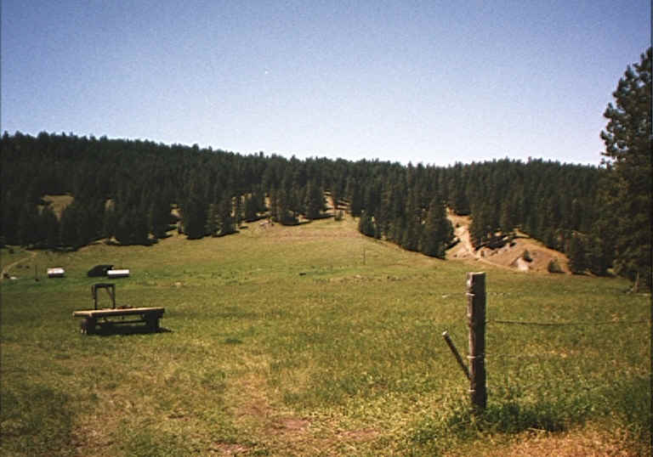

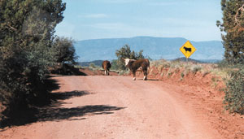

**Parks and Recreation Trends**

Emerging trends within park and recreation planning in Washington State should be looked at to help identify future demand and needs. The following trends were highlighted by the Recreation and Conservation Office (RCO) and include both state and national surveys and research. Those trends relate to specific opportunities within the County. People are busy and have to weigh the time available for work, live, and play. Key trends to consider include:

• Aging population: Older and retired populations continue to grow within the county with many expected to stay active likely demanding more recreation opportunities

• Ethnic diversity: County is diverse with non-native speaking residents that should be considered in marketing and services

• Changing lifestyles: More generations and changing work patterns are creating off peak demand on facilities and less structure and more options for multi-generational activities

• Physical activity: An increased interest in physical activity has emerged as obesity rises in children and adults throughout the country

• Convenient recreation: People are getting busier and costs for travel are increasing causing an increase and interest in recreating closer to home and work Recreation preference

# PLANNING AND SERVICES AREAS

## **WHAT AREA ARE WE PLANNING FOR?**

The planning area (see Planning and Service Area map on Page 18) consists of those privately owned lands outside the corporate limits of the Counties thirteen cities and towns. For the County as a whole, only an estimated 23% of the land is presently in private ownership. The breakdown of private ownership that is unincorporated (the planning area) versus incorporated was not calculated for this plan.

## **WHAT IS OUR SERVICE AREA?**

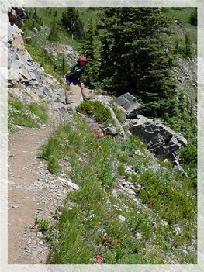The service area includes primarily Okanogan County; however parks and recreation facilities in the County are used by people from all over the region, state, country, Canada and other countries all over the world. In addition the County and connecting U.S. Forest service roads throughout much of the County provide access to a wide array of recreational activities and are in important part of the service area.

The Plan recognizes the importance of recreation-seeking visitors, who contribute $9.0 million annually in trail-related retail and hospitality expenditure revenue to the Methow Valley economy alone. As shown by the comments in the summary of the Visitors Profile Study in the Public Participation section of this Plan, people visit the region specifically to experience recreation opportunities unique to the physical climate of the county.

A comprehensive definition of the County’s service area is difficult as a result of the wide range of users and wide array of the County’s recreational opportunities. Okanogan County is a true four-season destination for the people from all over the state, the nation, and increasingly, the world. Residents of the County and its visitors are avid users of an amazing variety of opportunities, from mountaineering and snowmobiling to fly-fishing and driving for pleasure.

**PLANNING AND SERVICE AREA MAP**

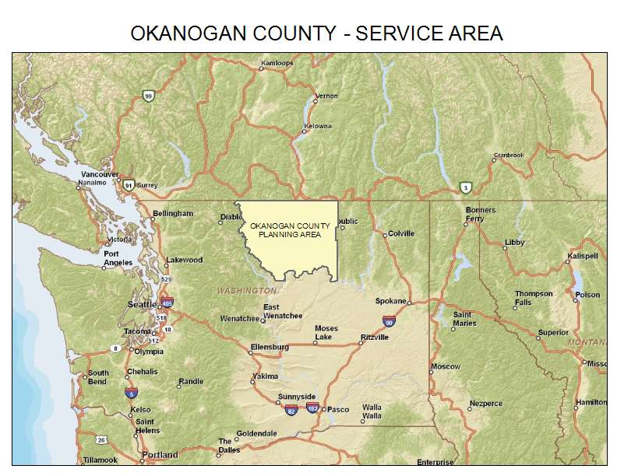

**INVENTORY**

For the purpose of this Element, the service area has been defined as primary and secondary. The **primary** service area includes North Central Washington and South Central British Columbia. The **secondary** service area includes the Puget Sound/Southwest British Columbia, the Columbia Basin and Spokane/N.E. Washington/North Idaho.

## **WHAT RECREATIONAL FACILITIES CURRENTLY EXIST?**

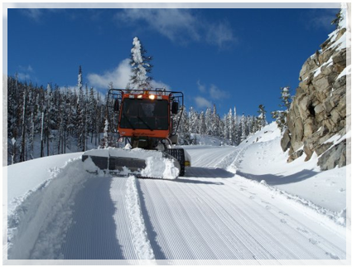

While a large number of recreation facilities exist in the County, Okanogan County’s involvement in parks and recreation activities and facilities is limited to a network of Sno-Parks, grooming a 437.7 mile system of interconnected snowmobile trails, operation of the Okanogan County Fairgrounds, The Similkameen River Trail, Whistler Canyon Trail, Sa-Teekh-Wa Park and administration of grant funds for development of portions of the Methow Community Trail.

**The Similkameen River Trail is the first urban trail in the Okanogan Valley. Explore the rich history of the Okanogan along this scenic path - Oroville**

Other than the Fairgrounds, the parks and recreation facilities and activities operated, supported and/or planned by the County are linear in nature.

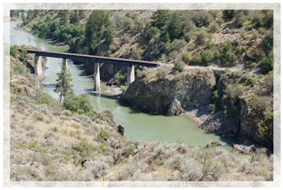

**A snow groomer working on Baldy Pass near Conconully. Over 400 miles of groomed trails are available for recreation**

The trail-grooming program is funded through the 1971 Snowmobile Act, which was amended in 1975 to provide funding for snowmobile trails and grooming. In Okanogan County, this program is a cooperative effort between the county, Forest Service, many private landowners, and the State. A local Snowmobile Advisory Board provides assistance and recommendations to the Public Works Department on improvements and operation of the Sno-Parks and connecting trail networks. Maps illustrating the County’s current snowmobile trail and Sno-Park system are included in Appendix G.

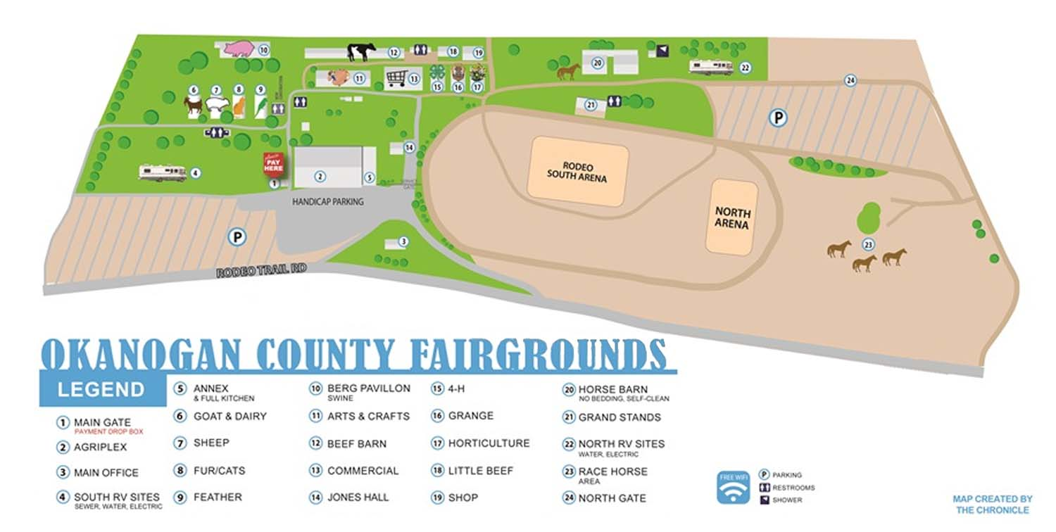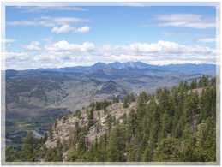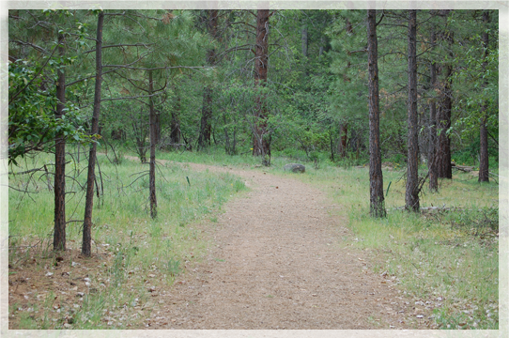

**The Whistler Canyon Trail, 3 miles south of Oroville offers spectacular views of the Okanogan river valley and a best chance to view Big Horn Sheep.**

**Sa-Teekh-Wa Park, accessed by a suspension bridge from down town Winthrop honors the heritage of the First Nations. Trail signs describe history and environment.**

**The County Fairgrounds provides a wide range of opportunities for recreational pursuits and is managed by the Okanogan County Park Board. The fairgrounds offer facilities for equestrian events, rodeo and other recreational activities. The Agri-plex, a 24,000 square foot building with a 3,600 square foot annex including a commercial kitchen, provides a facility for conferences, trade shows and other special events.**

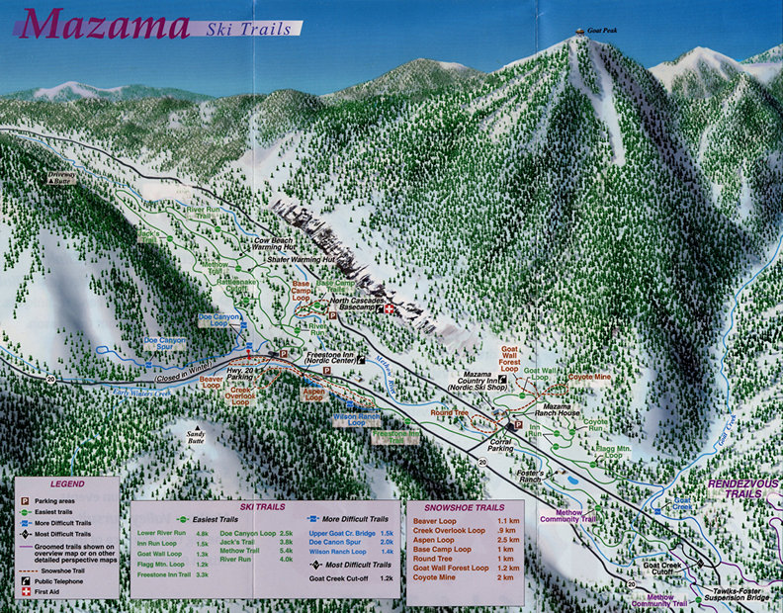

In June of 1990, the County joined a cooperative, citizen’s led effort to build twenty-six miles of ski and bicycle trails in the Methow Valley. The effort includes the County, the Methow Institute Foundation (MIF), the Methow Valley Sports Trails Association, (MVSTA), the U.S. Forest Service and the State. Construction of the trails was managed by the MIF and has been funded through grants to the County by the Recreation and Conservation office (RCO) and other state and federal sources. Trail maintenance is the responsibility of the MVSTA with portions of the trail operated under a U.S. Forest Service Special Use Permit. Maps illustrating the Methow trail system are included in Appendix G.

There is also a wide array of park and recreation facilities operated by cities and towns, non-profit organizations, Washington State through the State Parks, the Department of Natural Resources (DNR), the Department of Fish and Wildlife, and the federal government through the National Park Service and the U.S. Forest Service.

There are approximately 65 sites operated by cities, with various degrees of development. The communities of Tonasket, Omak, Okanogan, Brewster and Twisp have outdoor swimming pools. Oroville, Tonasket, Omak, Okanogan, Brewster and Pateros maintain public boat launches. Nearly all communities have at least one sports field, with the larger communities having recently developed new and larger fields.

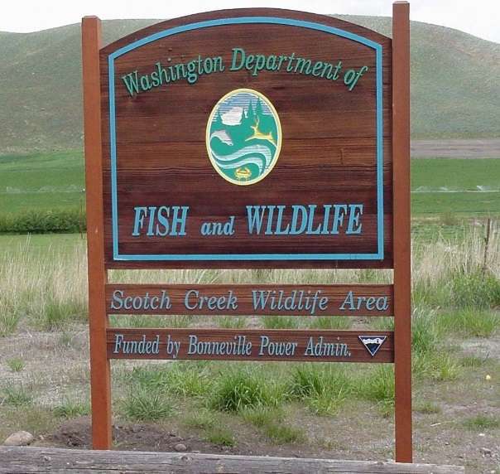

There are 6 golf courses in the County – Alta Lake, Lake Woods, Bear Creek, Okanogan Valley, Gamble Sands and Oroville. All but the Gamble Sands and Alta Lake are nine holes with the courses primarily privately owned and operated.

There are two Sno-Parks dedicated for Nordic skiing. One is located at the South Summit on Loup Loup Pass and the other in the Okanogan Highlands east of Tonasket. Both Sno-Parks feature access to groomed Nordic ski trails maintained by local non-profit organizations using state grant funds. There are also two alpine ski areas. The Loup Loup Ski Bowl at the Loup Loup Summit and Sitzmark, near Havillah east of Tonasket are both operated by non-profit organizations. Both areas feature a chair lift and variety of terrain. The Loup Loup Ski Bowl is operated under a U.S. Forest Service Special Use Permit while Sitzmark is located on leased private land and land recently purchased by the non-profit group that operates the area.

Washington State operates four state parks in the County, the DNR operates eight sites and the Department of Fish and Wildlife has numerous river, lake and hunting area access points. The Okanogan National Forest has 26 trailheads and 39 developed campgrounds, and additionally allows dispersed recreation in 627,992 acres of wilderness area, 357,761 acres of non-roaded forest areas, and 634,106 acres of roaded forest area. The North Cascades Scenic Highway passes through 129,502 acres on the National Forest. In 2009 the Okanogan National Forest recorded a total of over 361,000 site visits. A site visit is the entry of one person into a NF site of area to participate in recreation activities for and unspecified period of time. The Federal Bureau of Reclamation also provides recreational opportunities via several access sites along the Okanogan River. The Bureau of Land Management also provides a boat launch, camping and picnic area at Palmer Lake, dispersed campgrounds on the Similkameen River, A trail at McLaughlin Canyon and is joint manager with Okanogan County for the Similkameen Trail.

In addition to the more active outdoor recreation opportunities the County is the home of many significant historical tourist attractions including the museums in Okanogan, Oroville, Winthrop, Conconully, Pateros, the Stampede Museum, the Tribal museum in Coulee Dam and the Fort Okanogan Interpretive Center. Historical signs identify sights across the County.

Community events throughout the County also provide opportunities for recreation. The major public draws such as the Omak Stampede, Coulee Dam’s Laser Light Show, Winthrop 49er Days, Oroville May Day, Tonasket Founders Day, Pateros Apple Pie Jamboree and the Chesaw Rodeo bring tourists from around the region and are really part of the recreational scene. In addition, the Methow Valley Sports Trails Association holds a variety of trail-based events throughout the year in the Methow Valley (Sunflower Relay, Cutthroat Classic, Mountain Bike Festival, Winter Nordic Ski Events).

The private sector is a significant contributor to recreation opportunities. From heli-skiing in the North Cascades to ice skating in Winthrop, the private sector provides myriad opportunities for enjoying outdoor recreation in the County.

See Appendix A for a complete inventory of parks and recreation facilities in Okanogan County.

**WHAT PLANS ARE IN PLACE?**

**Okanogan County Plans:**

**Okanogan County Trail Plan**

In 1980, Okanogan County prepared a trail plan that identified seventeen trail routes and possible funding sources. A major priority identified at that time was a bicycle trail between Okanogan and Omak.

**Methow Review District Plan**

In 1990, Okanogan County adopted a Comprehensive Recreational Plan for the Methow Review District. This Plan focused primarily on trail systems for the Methow Valley.

**Omak-Okanogan Greenway Plan**

In 1994 the County retained a consultant to prepare a study of the feasibility and alternatives for this trail. The study was completed but not adopted.

**Okanogan County Comprehensive Parks and Recreation Element**

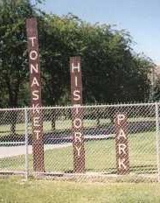In 1993, the County and their consultant prepared the first Park and Recreation Element for the Okanogan County Comprehensive Plan.

**Upper Methow Valley Comprehensive Plan**

In 2000, the County updated the plan for Sub-Unit A as identified in the Methow Valley Addendum. The update included revised goals, policies and direction for parks and recreation in the Upper Methow Valley.

**Comprehensive Recreational Plan for the Methow Review District 1989**

In 1989 the County prepared a parks and recreation plan for the Methow Review District as part of the effort to construct the Methow Community Trail.

**Comprehensive Outdoor Recreational Plan March 2004**

In 2004 the County prepared a parks and recreation plan. Following the plan, the Similkameen Trail, Whistler Canyon Trail and Sa-Teekh-Wa Park, were developed.

**Town, City and Non-Profit Plans:**

MVSTA Master Plan 2018

Brewster Park and Recreation Plan 2002

Omak Park and Recreation Plan 2020

Twisp Trail and Recreation Plan 2014

Tonasket Park Plan draft 2020

Winthrop Parks and Recreation Plan Draft 1997

City of Okanogan Parks and Recreation Plan 1996

Oroville Comprehensive Park and Recreation Plan 1989

Methow Valley Trails Plan 1984

A Bikeway Criteria Digest 1973

**Federal and State Plans:**

The BLM and USFS are currently working on plan updates.

See SCORP Inventory in Appendix B.

# PLANNING FOR THE FUTURE

## **GOALS**

Okanogan County continues to explore the various roles recreation plays in the health, safety, and well-being of its citizens and its potential to increase the area's economic base. Recreation, especially the availability of quality facilities and opportunities, not only enriches the lives of those who participate, but also improves the physical and mental health, safety, crime prevention, and citizenship of a community. Parks and recreation make a substantial contribution to the "quality of life" and economic future for Okanogan County residents.

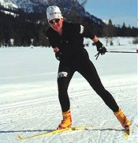Okanogan County is unique in Washington State as the largest county. It has a low population, high mileage distances between populations and extensive rural areas. It is less than 30% privately owned. Major County focuses are maintenance of existing park and recreation facilities, providing connections between existing and planned facilities, filling in “gaps” where facilities are needed, coordinating a comprehensive approach to facility maintenance and development and most importantly, providing a quality product for residents and visitors alike.

The goals for parks and recreation planning in Okanogan County are as follows:

**Goal 1 - Provide recreational opportunities to meet the diverse needs of residents and visitors**

**Objectives:**

1. Identify and analyze current and forecast future needs for the County concerning multi-modal recreation facilities enabling recreation for all ages, backgrounds and abilities.
2. Provide recreation opportunities and facilities for all age groups.
3. Provide for adequate, well-planned, and well-maintained parks, trails, recreation opportunities and open spaces within the County.
4. Encourage the development of year-round water-related access and recreation on the rivers, lakes and streams in the County.
5. Existing and new facilities should be accessible to the physically challenged
6. Identify and inventory current resources and using the County's new Standards list the recreation facilities and improvements needed to enable recreation for all ages, backgrounds and abilities at adopted levels of service.
7. Develop and implement a plan addressing routes, safety, travel modes, signage, and capacity issues for users for existing and planned new facilities.
8. Incorporate elements for visual separation, conflict management, and safe bridge crossings

**Goal 2 - Protect history, environment, culture, and agriculture**

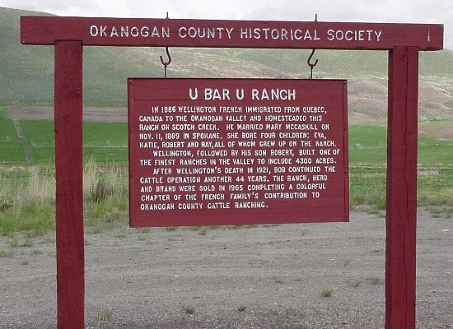**Objectives:**

1. Evaluate the environmental, cultural, historical, agricultural and economic implications for all multi-modal recreation usage or potential usage throughout the County.
2. Identify potential park areas and property of historical or ecological significance that should be protected or acquired.
3. Maintain existing ranches, farms and other open spaces for the direct and indirect impacts (access, habitat, aesthetics, etc…) on recreation and the economic well-being of the County.

**The Okanogan County Historical Society maintains signs describing the county’s history**

**Goal 3 - Promote economic stability within Okanogan County**

**Objectives:**

1. Identify land use regulatory, cost and other issues that may limit or improve the feasibility of identified park and recreation projects.
2. Encourage development of regulations that provide incentives to developers for retaining open spaces and establishing trails, parks, playgrounds and other recreation improvements.
3. Inventory recreational facilities belonging to Federal, State, Tribes, Cities and Towns, and other organizations along with their usage fees and impacts to County resources or plans. ID partnerships and support mechanisms’ to develop recreation generators.

**Goal 4 - Promote public awareness of the economic, environmental, interpretive and natural resource management values of recreation and leisure activities**

**Objectives:**

1. Establish and maintain an active advisory committee for parks and recreation planning and facilities development.
2. Develop reference materials for schools, organizations, taxpayers, businesses, residents, tourism promoters, and others featuring facilities available for proper use.
3. Develop and maintain cooperative partnerships with Tribal, Federal, State and local resource and recreation agencies and organizations to further an understanding of the values and impacts of recreation and open space on the County and its citizens.

**Goal 5 - Facilitate the development, maintenance, expansion and improvement of socially, economically and environmentally relevant public policy that supports recreation, parks and leisure programs and services**

**Objectives:**

1. Review existing and proposed regulations to ensure that public recreation oriented uses are provided with flexibility and a simplified, expedited permitting and review process, and that County tax policy reflect the public nature of such uses.
2. The County should conduct an economic benefit analysis on trails, recreational uses of the County Fairgrounds and other dispersed recreational uses.
3. Consider wildfire and snow management in the design and maintenance of parks and recreation facilities.
4. Encourage cooperation, communication and consistency among local, state and federal agencies when land use and management decisions are made that affect parks and recreation opportunities and facilities. Likewise, all parks and recreation planning should be performed in a similar coordinated fashion.

**Goal 6 - Promote the development and dissemination of information about the economic value of recreation in Okanogan County**

**Objectives:**

1. Work with the Okanogan Tourism Council to identify what opportunities are available, what opportunities are lacking, current efforts, what organizations are involved, share ideas, discuss changes that should be made and evaluate and monitor progress.
2. Encourage and foster recreational development as a stimulus to the economy.
3. Encourage an understanding of the contribution of recreational facilities and activities to the “quality of life” and the value of this contribution in stabilizing and strengthening the economic base of the community.
4. Conduct a Parks and Recreation User Survey every 5 years to reevaluate trends and changing needs and desires of county residents and visitors.

**Goal 7 - Develop and implement ongoing partnerships for resource sharing and cooperation among all entities with a stake in parks and recreation**

**Objectives:**

1. Focus partnership efforts on federal, state and local organizations that provide and promote parks and recreation opportunities.

**Goal 8 – Monitor, evaluate and revise the Capital Improvements Plan section of this plan on an annual basis**

**Objectives:**

1. Annually identify and prioritize projects, with cost estimates and potential funding sources.
2. Identify alternative revenue sources such as taxes, gifts, user fees, endowments, grants and other.

**Goal 9 - Identify a county agency or organization as the lead entity for implementation of this plan and the objectives herein**

**Objectives:**

1. Identify a specific position in County Government responsible for the implementation and periodic review and update of this plan.
2. Prepare and submit grant applications for identified priority improvements to the Washington State Recreation & Conservation Office and other appropriate funding sources.
3. Initiate and maintain regular Park and Recreation meetings with interested residents, organizations, city, county, and tribal officials.

## 

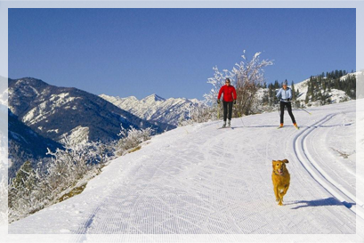

## **Methow Valley Community Trails offer year round recreation.**

## **DEMAND/NEED ANALYSIS**

This portion of the plan focuses on the demand on existing facilities and programs and the need for new and/or improved facilities and programs. Data and input for the analysis relied on many sources of information with the Paths and Trails Advisory Committee providing a sounding board and important review body as the plan was prepared.

The Committee relied on input collected during the public review process, the results from public meetings and a web-based survey conducted in December 2012.

###### **PATHS AND TRAILS COMMITTEE**

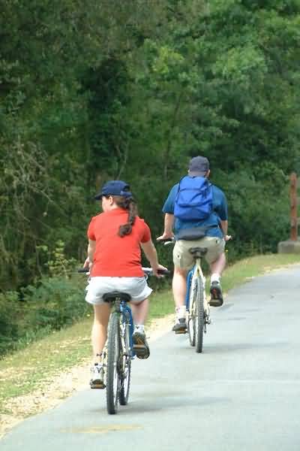The purpose of this advisory committee is to guide preparation of this element of the Okanogan County Comprehensive Plan and make recommendations to the Planning Director and the Okanogan County Board of Commissioners on the implementation of this element based on input from the public and their own expertise. Committee members were solicited from the general public, and chosen by the County Commissioners. There are eight positions on the committee.

The first advisory committee meeting was held on November 2, 2012 at 1:00 in the Commissioners Hearing Room. The committee meets monthly to guide and assist in the development of this plan.

## **PUBLIC PARTICIPATION**

### Public Participation Process and Survey Results:

**Public Meetings**

The process to update the 2012 Parks and Recreation Element began with a series of workshops held around the County. Concurrent to the workshops, an extensive survey was offered across the service area. A complete list of survey results and general comments can be found in Appendix C.

Due to the Covid 19 virus the county has sought information from the Towns, Cities and agencies that offer recreation across Okanogan County. Another survey for 2020 was also offered to all, but sought to learn from recreation groups across the county.

A Public Meeting to review a Draft of the Plan held on January 18, 2012 kicked off a comment period that ended on February 27, 2012.

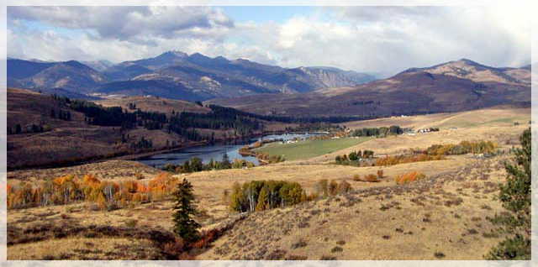Pearrygin Lake near Winthrop features a State Park on the north shore.

### Summary of Visitors Survey

In December 1999, the North Central Washington Rural Tourism Network and the Okanogan County Tourism Council hired RJR and Associates to conduct a Visitor Profile and Preferences Study. The study had five components:

* Focus group interviews with Seattle-area residents who have recently visited Okanogan County and/or North Central Washington for pleasure
* Interviews of providers of visitor services/products in Okanogan County
* A survey of over 400 attendees at four special events in Okanogan County
* Analysis of surveys of respondents to Okanogan County ads in the Washington Lodging and Travel Guide
* A presentation of locally-gathered visitor data

### Focus Groups

Focus groups were conducted in December 1999 in Bellevue, Washington with people who recently vacationed in Okanogan County and in North Central Washington. As stated in the report, “this research was designed to explore a variety of issues including how visitors refer to this part of the state, what appeals to them about the area, the degree to which their visits were planned or impulsive, how and where they gathered information about the area, their inclination to visit again, and recommendations they’d make to business owners and others who’d like them to vacation in the area again.”

### Interviews of Providers of Visitor Services/Products

Below is a summary of the report’s findings that are most relevant to Parks and Recreation.

* The combination of warm and sunny weather, the striking natural beauty of the area, a multitude of things to do, and the absence of crowds make North Central Washington and the Okanogan region very appealing areas of the state.
* Respondents were very positive about their visits to this part of the state and appeared to be very likely to return.
* Three days may be the practical minimum for a visit to North Central Washington.
* Visits to the area tended to be planned rather than impulsive.
* Once at their destination in North Central Washington, many of the decisions about things to do were made impulsively.
* Many of these visitors appeared to be interested in learning more about this area of the state.

In December of 1999 forty-four owners (or staff) of Okanogan County businesses that typically provide products or services to visitors were interviewed. Businesses included gift shops, restaurants, galleries, retail stores, lodging, and mini-marts.

* 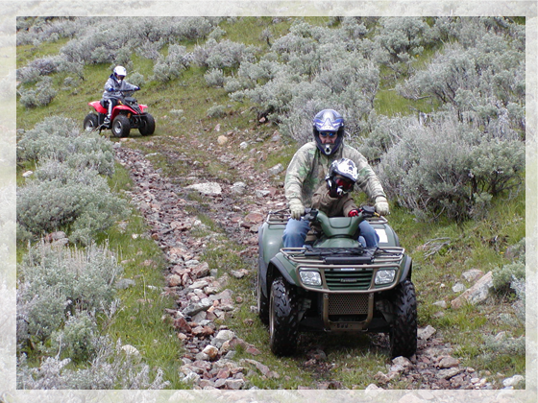What kinds of questions visitors typically ask
* How respondents (front-line people who contact visitors on a regular basis) answer questions about their immediate area, and the surrounding region
* How often visitors ask questions about the region-at-large
* What informational materials work well, how might they be improved, and what else is needed
* What kinds of theme maps would be useful

The information most frequently sought by visitors, according to those interviewed, includes: directions; dining-out possibilities; activities; and public restroom locations (in order of frequency). Visitors also inquire about shopping; weather patterns; local culture and lifestyles; and lodging.

In answer to questions about what to do around here, the majority of businesses mentioned outdoor activities, including swimming, fishing, hunting, hiking, camping, golfing, skiing and snowmobiling,

Existing maps and brochures/guides are deemed to be the most useful materials for fielding visitor questions about things to do in the immediate area.

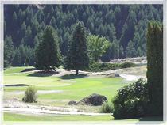Service providers field frequent inquiries from visitors interested in visiting other more-distant places within the region. In fact, 64% of the respondents say they are asked questions about the region at-large fairly or very often. This finding lends support to the notion that opportunities exist to “pass the visitors on” within the county and North Central Washington region.

**The Oroville Golf Course is one of six facilities in the county,**

Forty-seven percent of interviewees answered questions about places to visit in the region (within an hours drive) using personal experience, as compared to using brochures and maps to answer question about local activities.

**Survey of Special Events Attendees**

Four hundred attendees out of 7,760 were interviewed in the summer of 1999 at the following events (one hundred interviews at each event).

* Roots Mountain Reggae Festival/Concert; July 24-25 (Tonasket area)
* Omak Stampede; August 11-15
* Pateros Hydro Classic (7th Annual); August 28 – 29
* Methow Mountain Bike Festival; October 1-3
* Of those attending special events, the majority came from North Central Washington (44%) or from Western Washington (42%), with a small number coming from Eastern Washington or from outside the state or country.
* Camping was listed as the most common activity for special event attendees. Fishing, other special events, sightseeing, and hiking were listed as the next most popular activities.
* Approximately 86% of all event attendees at least spend a night in the area. In fact, approximately two thirds of all attendees spent two or more nights in the area.
* Of those staying overnight, most camped (42%) or stayed at the home of friends or relatives (30%). However, this varied depending on the event. Most attendees of the Roots Mt. Reggae festival camped (96%), while attendees at the Mt. Bike Festival were split between camping (47%) and motels (46%).
* Ninety-four percent of attendees said they would probably visit the region again.
* Weather/climate, scenery, and friendly people were the most common “likes” mentioned by respondents, regardless of which event they attended;

From the “Overview of Tourism in Okanogan County”:

Travel spending in Okanogan County (1997) was estimated to total $99,130,000. That figure equates to $2,582 per capita (or, per county resident). When compared to the state average of $1,633 per capita, it becomes clear that tourism contributes significantly more to Okanogan county citizens than it does to citizens in most counties: Travel spending in Okanogan County, per capita, was 58% greater than the average, per county.

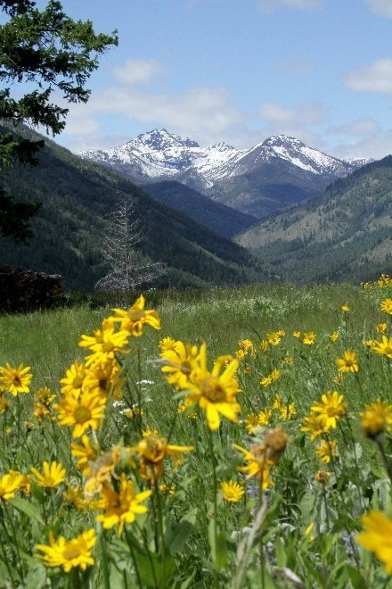**Executive Summary**

This economic impact analysis of the Methow Valley recreational trail network and appurtenant land resources has been prepared for Methow Trails. The intent of the 2015 study is to update a 2005 study and broadly assess the range of economic impacts of the trail network on the local and regional economy.

Key to the report are the findings of two surveys conducted in winter 2015 with three groups: Methow Valley residents, trail users (local and non-local), and area businesses. In sum, 504 respondents participated in the resident/trail user survey, and 93 businesses responded to the business survey. Additional methods were used to define the range of economic impacts, direct and indirect, related to Methow Valley trail lands and activities they offer.

**The Big Picture** ***Trail User Expenditures***

* Nearly $6.7 million dollars in direct expenditures are made annually (in 2014 dollars) to the Methow Valley economy by local and non-local trail users.
* Trail user (local, resident, non-local) expenditures average $1,793 per trip.
* Trail user spending is heavily concentrated in the service sector. Lodging remains the top spending category, at about 28.3% of all expenditures. Restaurant/food/grocery expenditures presents a combined average share of about 38.4%, and purchase/rental of sporting goods and recreational equipment has a pooled average expenditure share of about 12.9%.
* More than 72% of business survey respondents indicated a peak season dependence on visitors, with 48.4% ‘highly dependent’ on visitors and 23.7% ‘somewhat dependent’.
* Business survey respondents indicated that the number of visitors who came to the Methow Valley to take advantage of its trail network had increased significantly (23.7%) or increased somewhat (28.0%) over the course of time they have been in business.
* Business survey respondents indicated that summer is the season in which the greatest average percentage of revenues for area businesses (39.0%) are generated by visitors using the trail network for non-motorized recreation, followed by winter (35.9%).

***Indirect Economic Impacts***

* Over $5.7 million dollars of induced or secondary expenditures within the Methow Valley’s economy can be attributed to the Methow trail network, and related natural resource-based recreation opportunities unique to theMethow Valley.
* 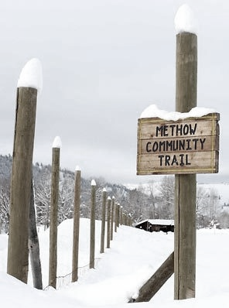The Methow trail network plays strongly intorespondents’ real estate purchasing decisions. 89.7% of the 185 respondents who addressed the question had considered buying real estate in the Methow Valley. Of this, 99.4% indicated that the trails network was either ‘most important’ (71.8%) or ‘important’ (27.6%) in their purchasing deliberations.
* 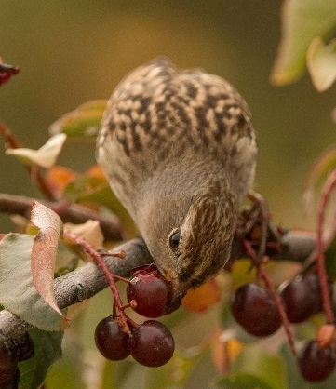People buying homes and real estate in the Methow Valley are willing to pay an average of 9.02% ($19,412) more per acre for properties near trails and particular environmental/amenity characteristics (0 to ¼ mile) than for properties without these characteristics (e.g. scenic vistas, open space, agricultural lands, parks, forest lands, trails, etc.). For properties between ¼ to ½ mile from amenity lands, buyers are willing to pay 6.12% ($13,182) more per acre, on average. Overall, property value impact is attenuated for land and homes further away from regional trails and open space. This suggests that greater tax revenues are produced by the sales of real estate with, or proximate to lands with particular environmental amenities.
* Revenue generation for area businesses, by group, was highest for ‘Nature Enthusiasts, Wildlife Viewers and Birders’, ‘Hikers and Trail Runners’ and ‘Cyclists’, at 81.3%, 80.0%, and 79.9%, respectively.
* The combined active and passive use benefit for the network of lands supporting Methow trail lands was estimated to be $21.8 million per year for the region.[1]

***Employment Impacts***

* While the Methow Valley region comprises about 16.3% of the county’s total population, on average across all industries, it provides about 19.2% of all employment.
* By industry, the Methow Valley provides nearly 40% of all employment in the county in the ‘arts, entertainment, and recreation, and accommodation and food services’ sector. The second largest employment sector is ‘professional, scientific, and management, and administrative and waste management services’, which provides almost one-third (32.2%) of all sector related employment in Okanogan County. Other sectors contributing a significant proportion of jobs against county total employment include wholesale trade (22.6%), construction (20.2%), finance, insurance, and real estate (20%), and manufacturing (19.2%).
* By occupation, those employed in service industries in the Methow Valley region represent 21.6% of Okanogan County’s civilian workforce. The second largest segment, as a percent of the county total, is management, business, science, and arts occupations at 20.4%.
* Overall, Okanogan County experienced an annual rate of employment growth of -3.58% from 2005 to 2014. The Methow Valley region fared somewhat better with a ‑1.46% annual employment growth rate for the period. Of interest for the 10-year period is the 11% increase in full-time jobs for the Methow Valley region. *Compared against the 2005 business survey, 32% fewer businesses participated in the 2015 study. Extrapolation of current study data reflects an annualized average of 877 jobs for 2014, or about 580 FTE and 297 PTE jobs, which represents about 30.2% of the total 2,900 jobs estimated for the region (1,917 FTE and 983 PTE).*

**Methow Trails, through its trail system, programs and related recreation-based activities generated the following economic impacts for the local and regional economy in 2013:**

* An estimated 183.8 jobs (121.5 full-time jobs and 62.3 seasonal full-time and/or part-time jobs), or 152.7 FTEs can be directly accredited to the Methow trail system and the network of related recreation and supporting activities. Purchases of goods and services made by these individuals supported an additional 25.8 induced jobs in the region.
* 30.2 indirect jobs were supported by $11.4 million of local purchases made by businesses supplying services to Methow Trails and related recreation-, services-, and tourism-related businesses.
* $5.7 million of direct wages and salaries were received by the 183.8 directly employed by Methow Trails and the Valley’s related recreation-, services-, and tourism-related businesses.   
  Re-spending of this income created an additional $871,536 of income and consumption expenditures in Washington, principally in Okanogan County. Those holding indirect jobs received $982,444 in indirect income.
* Businesses providing services to Methow Trails and the region’s recreation-, services-, and tourism-related businesses received some $22 million of revenues.

***Tax Impacts***

* In the period between 2012 and 2014, visitors to the Methow Valley spent an estimated average of $49.7 million annually in direct travel spending in the region. Of this, approximately $18.6 million annually can be attributed to trail users and other visitors attracted to the area’s natural resources and outdoor recreation opportunities.
* Expenditures by all trail users (resident, local, and non-local) for the period between 2012 and 2014 generated an estimated annual average of $292,740 in local (city and county) tax revenues, $94,391 in state-shared transient lodging taxes, $97,269 in additional hotel/motel taxes, and $211,896 in state taxes.
* Tax receipt distributions, for Twisp and Winthrop alone, attributable to all trail users and other visitors attracted to the Methow Valley’s open space **and outdoor recreation opportunities over the 2012-2014 period represent an average 24.1% of Okanogan County’s regular state-shared lodging tax, and about 31.3% of the county’s additional special lodging taxes collected. Similarly, tax receipt distributions for other areas of the Methow Valley region within unincorporated Okanogan County represents an average of 8.5% of the County’s regular state-shared lodging tax, and 7.7% of the County’s additional lodging taxes collected. Combined, for the 2012-2014 period, Methow Valley region’s lodging tax contributions represent an average of 71.6% of those taxes collected by Okanogan County.**

***Resident / Trail User Views & Values***

* Almost 91.9% of both resident and trail user survey respondents indicate their access to and the provision of public and private recreational facilities in the Methow Valley is very important (79.6%) or important (12.3%).
* 84.3% of trail user and 76.0% of resident respondents say the Methow trail network was the most important factor to their average visit, with another 14.5% and 20.0%, respectively, indicating the trail network was an important factor.
* Trail users reported peak trail months, in order of use/visits, as February, January, and December, with 90.2%, 85.6% and 68.4% of trail users reporting use in these months, respectively. Similarly, the 2005 and 1998 studies reported February, January and December as the primary months for trail use. There were slight increases in visitation in August, September, October and November over 2005, but slight decreases in April and May.
* Resident and trail user respondents feel strongly about the protection of open space and aesthetic beauty in the Methow Valley. A combined average of 83.0% of all respondents stated that they felt it was either ‘extremely important’ or ‘very important’ to preserve the area’s undeveloped open space. Further, a combined average of 84.1% of all respondents reported that the area’s natural beauty was ‘extremely important’ or ‘very important’.
* As in 2005, resident and trail user respondents indicated the top three reasons or characteristics influencing their decisions to move to or visit the Methow Valley are, in order of magnitude, 1) proximity to natural resources, 2) natural beauty and 3) rural character.
* The median length of non-local trail user visitor stays in the Methow Valley is about 6 days. These visitors report spending an average of $298 locally per day, while local trail users/residents (largely secondhomeowners) stay an average of 11.7 days per visit, with average daily expenditures of $228.[2]

## **DEMAND/NEEDS SUMMARY**

It is clear from public response that the citizens of Okanogan County and those that visit the County place a very high value on recreation, and have strong a desire for new and/or improved recreational facilities

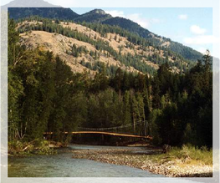

The focus of this plan is outdoor recreation. However, the County is in the position of supporting local community efforts to improve and expand indoor and outdoor recreational opportunities. The County can also actively work with local organizations, state and federal governments, utilities and others on long range recreation planning, maintenance of existing facilities and development of new facilities that connect existing and proposed recreational opportunities.

The following Action Plan proposes first to proceed with those projects and programs already underway or which exist and require ongoing maintenance. A high priority is continuation of an enhancement existing County park and recreation projects, including the grooming of snowmobile trails and improvements at Sno-Parks, and the continued cooperation on developing both motorized and non-motorized trails in the Methow Valley and north County areas. The existing facilities are valued and used by County residents and new projects should not detract from them.

The second recommendation is that the County Commissioners establish a mechanism for plan implementation and ongoing citizen participation through the designation of an Outdoor Recreation Coordinator participation of an advisory body to help with implementation of this plan.

The third recommendation is that a series of feasibility studies on indoor recreation facilities, outdoor recreation facilities, and river and lake developments be conducted.

A fourth piece is recognition of the important role the County and U.S. Forest Service road systems play in providing both access as well as opportunities for enhancing recreation.

The final piece of the action plan is coordination and cooperation.

|  |
| --- |
| **ACTION PLAN** |
| Outdoor recreation plays a major role in the economy of Okanogan County. Implementing this plan will take time, money and dedication, but the results will be a stronger parks and recreation system and continued support and growth of that system. Leadership is a vital aspect of cohesively implementing a parks and recreation plan. Okanogan County is the best entity to fill this leadership role. The parks and recreation plan identifies proposed action items. This list and the accompanying discussion form the foundation for the Outdoor Recreation Capital Improvements Plan (CIP). |
| **Trails** |
| Priorities for trail development have been established to ensure the safest and highest potential use trails are developed. Trail routes together with the needed improvements are listed in order of priority in the Capital Facilities Plan. Segments of routes that are most hazardous to the trail user are accorded the highest priority. Roadways scheduled for work should be improved for trail use at the same time, and all new construction should provide improved shoulders for reasons of traffic safety, whether the road appears in this plan or not. These priorities should guide the County in its pursuit of new trails. However, this list should not preclude the County from participating in the identification and development of historic or other trails that would be beneficial to County residents. Rankings reflect local need. |
| A top priority identified during the public process was development of new trails and linkages, seasonal and/or year-round and motorized and/or non-motorized, between existing trails throughout the County. The following general recommendations are included in the plan related to creation of a viable trails program within the County. |
| 1. The development of trail routes along county road rights-of-way should be coordinated with, and incorporated in the County Engineer’s Six Year Program whenever possible. By doing so the development of trails or portions of trails can take place as county roads are maintained, improved and constructed. |
| 1. The development of any given trail route can proceed in stages as funding becomes available. As a short-term solution to the problem of safety, adequate signing should precede all other types of physical modification to the trail route. |
| 1. Various sources of funding should be actively pursued as a means of financing the development of trails. Funding in the form of grants, adding to the present level of funding from the state greatly, contributes to meeting the goals and objectives outlined in this plan. |

|  |
| --- |
| **Outdoor Recreation Coordinator and Advisory Committee** |
| Each area of the County has many distinct needs and desires, as well as needs common with other areas of the County. Implementation of this plan and initiation of an ongoing program for maintenance and development of outdoor facilities, creation of a forum to resolve trail use issues as well as establishing a mechanism for the type of coordinated and cooperative planning and development envisioned by this document requires the Outdoor Recreation Coordinator position in County Government. This individual would be charged with implementation of the Goals and Objectives contained in this plan. The Coordinator would provide a focus and point of contact in County government for what has been identified as an important part of the County’s economic future – maintenance and development of outdoor recreation facilities. |
| **Projects** |
| Appointment of Outdoor Recreation Coordinator and Advisory Committee The County Commissioners should appoint an Outdoor Recreation Coordinator and Outdoor Recreation Advisory Committee and charge them with the follow tasks:   * Organize and establish bylaws * Review outdoor recreation functions within County Government and provide recommendation on how to establish a formal Outdoor Recreation Program * Review plan and prepare meaningful Capital Improvement Plan and work to integrate outdoor recreation projects into County’s overall Capital Facilities Plan * Provide recommendations on amendments to Okanogan County Code and other ordinances and regulations described in this plan * Prepare recommendations on design criteria and guidelines for trailheads, river accesses and other recreation facilities that address solid waste, security, human waste, snow management, traffic management, signage, maintenance, etc… * Annually review and amend plan to reflect new and changing conditions * Provide review and recommendations on vacation of ROW or surplus of public lands |

|  |
| --- |
| Feasibility Studies |
| The goal of these studies will be to have a clear understanding of the need and demand for a variety of projects, the associated costs, available funding, and possible sites. After the feasibility studies, specific projects will be developed for each region of the County, and funding will be sought. The Outdoor Recreation Coordinator would manage the studies and the Outdoor Recreation Committee would provide review, opportunity for public input and guidance and direction to the County Commissioners throughout the process. |
| These feasibility studies will look at the County as a whole, and answer the following questions:   * Who are the potential users of different facilities? * What are the different levels of potential use? * Where in the County is the demand greatest? * What is the range of potential cost, both for ongoing maintenance and operation? * What are the financing options? * Where are the possible sites? * What citizen groups or governments maintain or are working for this type of facility? * How can the County and these groups or governments work together most effectively? |
| **Projects** |
| **Public Access to Rivers and Lakes** – The Demand/Need Analysis identified a significant desire for improved and expanded access to water bodies including identified “river trails” in the County as well as improvements to those accesses which already exist. County wide  **Off-Road Hiking and Biking Paths** – The Demand/Need Analysis identified a significant desire for continued maintenance and expansion of access to pedestrian (non motorized) and bike trails in the County. North County, Mid-County and Columbia  **Cross-Country Ski Trails -** The Demand/Need Analysis identified a significant desire for the on-going maintenance and high quality grooming of the Methow Valley cross-country trails.  Upper Methow and Columbia  **Nature and Interpretive Areas -** The Demand/Need Analysis identified a significant desire access to nature and interpretive areas and experiences preferable near urban centers with easy access and trails. North County  **Indoor Pool – recreation center -** The Demand/Need Analysis identified a significant desire for indoor year round swimming facility in all areas of the county.  **Picnic Areas -** The Demand/Need Analysis identified a significant desire for Picnic areas and play grounds. Mid County |
| Roads |
| The County, State DNR and U.S. Forest Service maintain miles of road that provide myriad opportunities for recreation from snowmobile trails in winter and access to lakes and streams for fishing in the spring to backcountry access in the summer and hunting areas in the fall. The existing road network that provides access to popular public destinations and the demand it serves must be considered an important part of recreation planning. Several roads in Okanogan County have now been identified for dual use allowing ATV or Snowmobile use. In addition the Forest Service and State DNR have identified roads for these activities. Maps of these roads are included in Appendix G, riders should check with respective agencies for current designations. |
| **Projects** |
| Non-motorized transportation – consider non-motorized access when planning and engineering new or upgrading of county roads, ROW acquisition etc  **Vacations or surplus of public land and row’s -** Consider recreational needs and opportunities prior to vacation or surplus of public land and rights-of-way and review past vacations of right-of-way to determine status.  **Bike Lanes –** There is a growing interest in road touring. Many residents and visitors commented on the need for bicycle lanes in high travel areas. High travel areas such as Elmway from Omak to Okanogan, Old 97 from Brewster to SR 20 and Hwy 7 from Janis Bridge to Oroville, Weeman Bridge to Winthrop should be studied prior to construction and include additional bike safety. |
| Coordination and Cooperation |
| The most effective way for the County to improve parks and recreation opportunities in the region is to actively engage in existing ongoing programs. Many Federal and State agencies maintain recreation improvements and engage in planning for improvements to such facilities. The same is true for the incorporated communities and a variety of non-profit organizations in the area. However, in order to be effective the County must provide a single point of contact (e.g. the proposed Outdoor Recreation Coordinator) with the charge to actively work with a wide range of agencies, communities and organizations. In addition the County should encourage the development of a process for resolution of disputes among users and supporters of non-motorized and motorized recreation. A list of such organizations follows with short descriptions of how a coordinated and cooperative partnership can further implementation of this plan.  No priorities have been assigned under this action area because it is important that the County pursue opportunities for coordination and cooperation as they arise or as they will further the goals and objectives of this plan. |
| **Projects** |
| Cities and Towns within the County – Every city and town in the County contains at least one park. The larger communities have a variety of development recreation facilities and nearly every community is actively pursuing upgrades, expansion and improvements to their parks. The following projects should be supported by the County: |
| * Okanogan – Completion of Sports Complex, Omak/Okanogan Greenway * Omak – Stampede Arena and Grounds Redevelopment project; new restroom/shower facility in Carl Precht RV Park, sports fields realignment, SR 97 Bridge Trail, * Tonasket - Chief Tonasket Riverfront Park development – access through County shop property, pedestrian access, fish observation deck, RV park, swimming pool. * Conconully - Most of the recreational opportunities in the Conconully area are under County, State or Federal jurisdiction. The Town supports the development of trails (e.g. connecting trail down Salmon Creek to old Ruby), improvement and expansion of the facilities in Conconully State Park, improved access to Conconully and Salmon Lakes and identification of mountain bike routes. * Oroville – PNT connection from City east and west, trailheads, connecting trails, East Lake Ball fields, and East Lake community trails. * Brewster – Riverfront trail completion, ball fields, Columbia Cove Park improvements * Pateros – Waterfront Trail and Park improvements, construction of playfields, park improvements, RV Park, extend trails, expand camping/tenting, outdoor interactive historical exhibits. * Twisp – Commons Park, playground at Twisp, Town Park, river trail, playfields at Airport * Winthrop – Ice rink, south end Pedestrian Bridge/Trail, Sa-Teak-Wa Park, Heckendorn Park, Cottonwood Park, river trail and connection to school. * Mazama – Community Trail System, Trailhead * Nespelem – Chief Joseph Rest stop, Bicycle lane to Agency * Coulee Dam – Douglas Park renovation * Elmer City - ? |
| **Okanogan County Parks Board –** The County Commissioners have formed a Parks Board to oversee the operation of the County Fairgrounds. It is imperative that parks and recreation planning considers the value and potential for the Fairgrounds as a source of a wide array of recreation opportunities |
| **Okanogan County Tourism Council** – The OCTC is at the forefront of developing informational and marketing materials and educational programs to attract visitors to the County and enjoy the plentiful recreational (i.e. snowmobiling, historical tours, special events) opportunities. This organization has an important role to play in keeping the County informed of the types of activities our guests are enjoying or seeking. |
| **Okanogan County Historical Society** – The Historical Society maintains a network of museums as well as historical signs throughout the County. The Demand/Needs Analysis identified access to history and culture as an important recreational pursuit. |
| **Economic Alliance** – The Alliance is the county-wide economic development organization. It is important that parks and recreation planning and implementation include an understanding of the potential for economic development. |
| **Confederate Tribes of the Colville Reservation** – The Colville Tribes have a Parks and Recreation Department that oversees a variety of formal and informal recreation opportunities on the Reservation. The Reservation abounds in opportunities for a wide variety of opportunities sought by residents and visitors therefore the Tribes are an important partner in parks and recreation planning and implementation. |
| **U.S. Forest Service** – The Forest Service is the largest provider of backcountry recreation in the Okanogan. With its network of trails, campgrounds, picnic areas and other attractions, the Okanogan and Wenatchee National Forest is an important recreational resource for county and visitors. The Forest is presently in the process of updating the “Forest Plan”. This is the time for the County to become engaged in the process to advocate for the maintenance of existing facilities and the development of new facilities consistent with this plan. |
| **U.S. Park Service** - The Park Service’s presence in the County is limited, however North Cascades National Park, Lake Chelan National Recreation Area and the Lake Roosevelt National Recreation Area host large numbers of visitors that pass through the County. The Parks also provide recreation opportunities for a large number of county residents each year. This makes maintenance and development of facilities in these Parks important to Okanogan County. |
| **U.S. Bureau of Land Management** – The BLM manages lands along the Similkameen River and elsewhere that may have potential for trail or other recreation development. It is important that the County maintain a relationship with the BLM to enhance cooperation and coordination of activities. |
| **U.S. Bureau of Reclamation** – The BOR owns and works with irrigation districts that manage water storage and delivery systems. Some of these facilities (e.g. Conconully and Salmon Lakes and pipeline/canal rights-of-way) offer existing as well as potential recreation opportunities. |

|  |
| --- |
| State Parks – Washington State Parks operates and maintains five parks in Okanogan County: Lake Osoyoos, Conconully, Bridgeport, Pearrygin Lake and Alta Lake. The Park facilities offer camping, water access and picnic facilities. The Parks provide an important asset for residents and provide an attraction for visitors. The County needs to work with State Parks to ensure that the facilities are open and maintained. In addition, State Parks has provided grant funding for over 20 years for the maintenance and grooming of miles of snowmobile and Nordic ski trails as well as development and plowing of SnoParks. |
| **State Department of Fish and Wildlife** – WDFW owns and manages significant acreage in Okanogan County and has developed and maintains water access points throughout the County. As a significant landowner and agency responsible for the management of fish and wildlife resources, the WDFW plays an important role in ensuring the existence and quality of hunting and fishing opportunities in the County. |
| **State Department of Natural Resources** – DNR is also a significant landowner and manager in the County. While most of the lands managed by DNR are dedicated to timber production, all is open for a variety of recreational pursuits. |
| State Department of Transportation – WSDOT maintains the principal arterials that connect Okanogan County to the “outside world”. These routes are, in many cases, the only means of access to and through the County and with only one exception, link all of the incorporated municipalities. In addition, WSDOT is the conduit for a variety of state and federal funding programs that can be used to improve pedestrian and bicycle access. |
| State Recreation and conservation Office – The RCO is one of the principle sources of grant funding for parks and recreation projects. Nearly all significant recreation projects in the County (e.g. swimming pools, athletic fields, picnic areas etc….) outside of the National Forest have been funded to some extend through this agency. This plan must be approved by the agency and updated every 6 years in order for the County to qualify for grant funding. |
| **Okanogan County PUD –** While the local PUD does not have the facilities that require extensive licensing and subsequent requirements from the Federal Energy Regulatory Commission like the PUD’s to the south, the utility does own properties and control rights-of-way with potential for recreational development. |
| **Douglas County PUD** – Douglas PUD is just finishing the relicensing process for Wells Dam. The existing parks in Pateros, Brewster and Bridgeport were developed by the PUD as part of current license requirements. Additional or improved facilities will be the subject of review and comment during the relicensing process therefore it is important that the County, Cities of Brewster and Pateros and other organizations work with the PUD to find opportunities to address the needs contained in this plan. |

|  |
| --- |
| **Farm Bureau – Agri-tourism** – There is a growing interest in the County and region to provide a more direct connection between agricultural producers and consumers as a means to maintain and revitalize the areas agricultural base. Agri-tourism provides opportunities for residents and visitors alike to learn more about agriculture as well as provide new economic activities. |
| **Upper Columbia Regional Fisheries Enhancement Group** – This organization has several planned projects that address many of the activities and opportunities supported by this plan. Projects such as the development of interpretive sites on Driscoll Island and the proposed International Salmon Center both tie into the County’s top outdoor recreation priority – the Pacific Northwest Trail. In addition the proposed research area along Okanogan River in the vicinity of McLaughlin and Keystone Canyons offer excellent opportunities for additional recreational and education trails. |
| Methow Valley Sports Trail Association – The MVSTA maintains and operates the Methow Community Trail System on a year round basis. This organization provides an excellent example of the type of partnerships with local organizations the County can participate in order to implement this plan. |
| Loup Loup Ski Education Foundation – The LLSEF operates the Loup Loup Ski Bowl under a Special Use Permit from the U.S. Forest Service. The Foundation has recently completed repayment of a loan used, along with an incredible amount of volunteer labor and donation of time, materials, equipment and money, to construct the quad chair lift. The Foundation has completed development of a new lodge, restrooms, tube tow and other much needed improvements. The LLSEF also maintains popular Nordic ski trails on Bear Mt. and at the Loup Loup South Summit and has been seeking grant funds to acquire better equipment for grooming the trails in the winter as well as improving maintenance in the summer. The County can be a valuable partner to the LLSEF as that non-profit begins to identify funding needs for desired improvements. |
| Sitzmark Ski Area – **Sitzmark Ski Area is dedicated to providing healthy and affordable winter activities for families and youth. The Sitzmark Ski Club supports this effort by developing and promoting low cost instructional programs in alpine skiing and snowboarding. Local school systems, both public and private, benefit from the midweek instructional programs the ski area offers, and weekend ski school allows local youth and families to learn to ski and snowboard close to home and at a reasonable cost.** |

|  |
| --- |
| **Pacific Northwest Trail Association** – This association is spearheading efforts to complete a trail from the Pacific Coast to Glacier National Park in Montana. In April of 2009 the trail was recognized as a National Scenic Trail. Efforts in Okanogan County have focused on access and development of an Oroville trailhead and a 3.5 mile segment of the Oroville – Nighthawk portion of the Washington and Great Northern rail-trail. Along with acquisition of property 3 miles south of Oroville for a trailhead and access to Whistler Canyon. Both facilities are part of the Pacific Northwest National Scenic Trail. |
| **Backcountry Horsemen of Washington** – This association is working with Okanogan County and BLM on the Whistler Canyon Trail a part of the Pacific Northwest Trail. BCHW maintains many of the trails on state and federal lands. |
| **Methow Valley Cycling (MVC) -** is a non-profit organization comprised of individuals, organizations and businesses committed to promoting bicycling – road, mountain, and cyclocross - for all ages and abilities in the Methow Valley. MVC is currently engaged in the process of inventorying all the trails in the Methow Valley for the purpose of creating a bicycle trails strategic plan |
| **Mazama Advisory Committee (MAC)** - MAC was created in 1984 when Okanogan County appointed a group of upper Methow Valley citizens to provide planning recommendations as part of “Sub-unit A”, which generally encompasses the upper Methow Valley from the Wolf Creek area (northwest of Winthrop) up through the Mazama area. Today MAC members continue to be appointed by the County Commissioners to advise the County on Land Use Planning. MAC is involved with Comprehensive Plan updates for the upper Methow Valley; development of a conceptual Master Plan for the Mazama Center area in coordination with property owners and local residents; and MAC comments to the County on land use proposals in the upper Methow Valley, including highlighting and recommending recreational options afforded by the various proposals.  **North Central ATV Club** - The North Central ATV Club has been established to promote the sport, be family-oriented, be good stewards and to educate the government and public about ORV use. The club maintains miles of trails in Okanogan County.  Omak stampede ?? |
| **Other non-profit organizations -** |

|  |
| --- |
| **Project Selection Criteria** |
| The Action Plan includes a wide range of actions, all of which have been identified as important to the County, from specific development projects to recommendations for changes in County policy. Actions listed as a High priority are based on the following criteria: |
| 1. Community priority as identified through the public participation process, surveys, questionnaires, written and oral comments, meetings and public hearings. 2. Level of potential use. 3. Potential for economic development. 4. Funding potential and possible partnerships. 5. Basic need for implementation of plan. |
| The priorities provided in this Action Plan are intended to provide some sense of urgency. All projects are considered important priorities that need to be accomplished to implement this plan, however the plan suggests that efforts be focused on those projects or activities rated as High. Projects can move to a High priority as funding and/or organizational support develops to promote the effort or a County road is being upgraded and other land use and access changes. |

|  |  |  |  |  |  |  |  |  |  |  |  |  |  |  |  |
| --- | --- | --- | --- | --- | --- | --- | --- | --- | --- | --- | --- | --- | --- | --- | --- |
| **Outdoor Recreation Capital Improvement Plan** | | | | | | | | | | | | | | | |
| The goals and recommendations of this plan will not be achieved if they are not financially realistic. The 6 Year Capital Improvement Program (CIP) helps to prioritize projects and to demonstrate each project's financial impact on Okanogan County. In addition to acquisition and construction costs, the County must consider long-term operation and maintenance needs. | | | | | | | | | | | | | | | |
| Capital improvement programs must be flexible to keep abreast of changes in community trends and demands. For this reason, the list of projects found in the CIP will be reviewed and updated on a consistent basis by the County as goals are met, funding opportunities arise, organizations commit to projects and needs change.  A brief description of each project follows the 6 Year Capital Improvement Program. | | | | | | | | | | | | | | | |
| **TRAILS** | | | | | | | | | | | | | | | |
| **Priority** | **Project** | **2020** | | **2021** | | **2022** | | **2023** | | **2024** | | **2025** | | **Cost Estimate** | **Potential**  **Funding** |
| **4** | **Adopt trail usage, purpose development criteria** |  | |  | |  | |  | |  | |  | | $5,000 | County |
| **5** | **Oroville to Nighthawk Trail, acquisition, improvements** |  | |  | |  | |  | |  | |  | | $800,000 | County, BLM, RCO, WDFW, Donations, Other |
| **5** | **Similkameen Trail - Oroville Trailhead, restroom** |  | |  | |  | |  | |  | |  | | $107,000 |  |
| **3** | **Whistler Canyon to Bonaparte Mountain** |  | |  | |  | |  | |  | |  | | $600,000 | County, BLM, USFS. Other |
| **5** | **School to Winthrop and Twisp, Methow Community Trail** |  | |  | |  | |  | |  | |  | | $1,000,000 | County, RCO, WSDOT, Methow Trails, WDFW, Donations, Other |
| **3** | **Driscoll Island Trail** |  | |  | |  | |  | |  | |  | | $300,000 | County, WDFW |
| **4** | **Oroville Community Trail** |  | |  | |  | |  | |  | |  | | $1,500,000 | County, City RCO, Donations, Other |
| **4** | **Rehabilitate Sandy Butte Trails** |  | |  | |  | |  | |  | |  | | $800,000 | USFS, County |
| **5** | **Winthrop Trailhead Facility** |  | |  | |  | |  | |  | |  | | $150,000 | Town, County, RCO, Donations, Other |
| **4** | **Sa Teekh Wa Park Trail** |  | |  | |  | |  | |  | |  | | $5,000 | County |
| **5** | **Paving of high traffic rec routes; Sun Mtn Thompson Rd, Little Wolf, Mazama Suspension Bridge Community trail (ADA), Cub Creek.** |  | |  | |  | |  | |  | |  | | $1,000,000 | USFS, Methow Trails, FHACounty, Grants, Donations |
| **3** | **High-elevation Nordic Ski Trail Development (Hwy 20, Boulder Cr, Cedar Cr, Klipchuck, Rendezvous)** |  | |  | |  | |  | |  | |  | | $750,000 | County, RCO, Donations, Other |
| **3** | **Mazama Fire Break Trail** |  | |  | |  | |  | |  | |  | | $800,000 | USFS, County, Other funding sources |
| **5** | **Methow Community Trail**  **On-going Maintenance** |  | |  | |  | |  | |  | |  | | $450,000 | County, RCO, other funding sources |
| **3** | **Golf Cart Trail - Pearygin Lake** |  | |  | |  | |  | |  | |  | |  | State Park, County |
| **4** | **Winthrop to Weeman Bike Trail** |  | |  | |  | |  | |  | |  | |  | DOT, County |
| **5** | **River Walk Trail - Winthrop** |  | |  | |  | |  | |  | |  | |  | City, County |
| **BRIDGES** | | | | | | | | | | | | | | | |
| **3** | **Mazama bridge- widen** |  |  | |  | |  | |  | |  | | $375,000 | | County, RCO, other funding sources |
| **5** | **Upper Goat Creek Bridge - replacement** |  |  | |  | |  | |  | |  | | $100,000 | | USFS, RCO, other funding sources |
| **3** | **USFS Pedestrian Bridge – Ballard Campground** |  |  | |  | |  | |  | |  | |  | | USFS, Grants |
| **Recreational Related Parking** | | | | | | | | | | | | | | | |
| **1** | **Chewuch River - New Sno-Park - toilet** |  |  | |  | |  | |  | |  | | $24,000 | | County. USFS, State Parks |
| **5** | **Bonaparte Sno-Park - Relocate - toilet** |  |  | |  | |  | |  | |  | | $42,000 | | County. USFS, State Parks |
| **5** | **Early Winters/ Hwy 20 Relocate Parking** |  |  | |  | |  | |  | |  | | $80,000 | | County, USFS, State |
| **3** | **Highlands Nordic Sno-park - Expansion** |  |  | |  | |  | |  | |  | | $15,000 | | County. USFS, State Parks |
| **1** | **Twisp River Sno-park - Expansion** |  |  | |  | |  | |  | |  | | $15,000 | | County. USFS, State Parks |
| **4** | **Crawfish Lake Snow-park - Expansion - toilet** |  |  | |  | |  | |  | |  | | $42,000 | | County. USFS, State Parks |

|  |  |  |  |  |  |  |  |  |  |
| --- | --- | --- | --- | --- | --- | --- | --- | --- | --- |
| **ORV** | | | | | | | | | |
| **3** | **Off-Road Vehicle Park and Trails** |  |  |  |  |  |  | $100,000 | County, Grants, Donations |
| **Equipment** | | | | | | | | | |
| **5** | **Grooming Equipment - Purchase** |  |  |  |  |  |  | $100,000 | County, Grants, MVSTA, Donations |
| **4** | **Whistler Canyon Trailhead facilities - toilet** |  |  |  |  |  |  | $40,000 | County, BLM, USFS, BCHW |
| **EQUESTRIAN** | | | | | | | | | |
| **3** | **Equestrian Facilities** |  |  |  |  |  |  | $100,000 | County, Fair, Grants, Donations |
| **4** | **Whistler Canyon Trailhead facilities - toilet** |  |  |  |  |  |  | $40,000 | County, BLM, USFS, BCHW |
| **OTHER** | | | | | | | | | |
| **5** | **Outdoor Recreation Coordinator and Committee** |  |  |  |  |  |  | $0 | County, grants |
| **5** | **Public Access to Rivers and Lakes** |  |  |  |  |  |  | $0 | County, Grants, Donations WADFW |
| **5** | **Non-motorized transportation** |  |  |  |  |  |  | $0 | County Staff |
| **4** | **Vacations or surplus of public land and row’s** |  |  |  |  |  |  | $0 | County Staff |
| **4** | **Mazama Biathlon Range** |  |  |  |  |  |  |  |  |

|  |
| --- |
| **TRAILS** |
| **Adopt trail usage, purpose and development criteria.** During 2012, the plan calls for the County Public Works and Planning Departments to work together on preparation and adoption of amendments to various transportation plans, zoning and development standards codes to incorporate the paths and trails standards, or a modified version thereof, included in Appendix E. The cost estimate of $5,000 includes primarily contributions of staff time for research, amendment preparation and public review and adoption. |
| **Oroville to Nighthawk Trail.** This project entails development of pedestrian/non-motorized trail on the old Great Northern Railroad corridor. The project starts at the town of Oroville and crosses the Similkameen River on a 375-foot span steel girder bridge, passing through a 1,832 foot tunnel and ending in Nighthawk. Three and one half miles of the 12.5 mile trail is now developed with funding being sought from a variety of sources to complete the estimated $1,200,000 project. Trail surface improvements, restroom facilities, property acquisition are some of the challenges to be resolved. |
| **Similkameen Trail.** Develop Oroville Trailhead facility, restroom, parking area, kiosks, picnic area, ongoing maintenance. |
| **Whistler Canyon to Bonaparte Mountain**. This project entails development of a pedestrian/non-motorized trail starting on SR 97 then up USFS Rd 100 to Summit Lake area across to Wilcox Mt Rd to Dry Gulch Rd, to Mill Creek (Highlands Trailhead). In 2010 the county purchased the property secured a Title ll grant and will begin trailhead construction fall of 2012. Trail improvements were completed by BCHW in 2011. |
| **School to Winthrop and Twisp, Methow Community Trail.** These Pedestrian/non-motorized trail extensions connecting Winthrop to Methow Valley School campus, the school campus to Twisp, and from Mazama to the USFS West Fork Methow River Trail has been in the planning stages for many years. The segment from Winthrop to the School campus will be designed as a first priority, property acquired, permits obtained and funding sought. The other segments will follow as support, time and funding permit. |
| **Driscoll Island Trail.** This pedestrian/non-motorized trail from Oroville to Driscoll Island is intended to be developed in cooperation with the International Salmon Center and extend to bottom of Whistler Canyon. The trail will need to be designed, property acquired, permits obtained and funding sought. The trail will link Whistler Canyon with the Similkameen Trail and provide a missing link to the National Scenic Trail. |
| **Oroville Community Trail**. With the acquisition of Veterans Park from the state parks. Oroville would connect developing east lake properties to the park and downtown shopping with shoreline trails and a bridge crossing the Okanogan River at the south end of Osoyoos Lake. |
| **Rehabilitate Sandy Butte Trails** – An existing network of trails needs to be rehabilitated to provide for non-motorized uses. |
| **Winthrop Trailhead Facility.** Town of Winthrop owns 4 acres that was purchased for development as a central trailhead for the Methow Community Trail. The plan calls for the County to work with the Town of Winthrop for the long-term development and maintenance of the planned facility. Remaining additions to the project include landscaping, signage, parking area improvements. |
| **Sa-Teak-Wa Park.** A private landowner donated approximately 12 acres of land within the Town of Winthrop a pedestrian trail and utility bridge connecting the property to downtown Winthrop was constructed in 2008. Further park and trail development is needed. |
| **Paving of high traffic rec routes;** Sun Mtn Thompson Rd, Little Wolf, Mazama Suspension Bridge Community trail (ADA), Cub Creek. Paving of roads that serve as early season high volume winter groomed trailswill aid in low snow year grooming of cross country ski trails. This will also help with a growing need for road maintenance on high trafficked summer roads used by the exponential growth in mountain bikers. |
| **High-elevation Nordic Ski Trail and Trailhead Development**. In response to warmer winter conditions, planning for and development of higher elevation non-motorized trails and trailheads in the Methow Valley is vital to the on-going sustainability of the MVSTA trail system. |
| **Mazama Fire Break Trail**. An established fire-break trail along the base of Lucky Jim Bluff represents an opportunity to make an additional link within the Methow Community Trail, and is of high value due to the late-season durability of the snow along the existing fire-break. |
| **Methow Community Trail Maintenance** - The county holds the right-of ways/easements and supports funding for theon-going maintenance of the Methow Community Trail including summer mowing, limbing, regular bridge upgrades or replacements, and winter grooming machine replacement costs to support the 200km Methow Valley network of non-motorized recreational trails. Regular replacement/maintenance of the MVSTA grooming equipment is essential for the reliable operations of the Nordic ski trail system in the Methow Valley. |
| **Pearrygin Lake Golf Cart Trail –** Pearrygin Lake State Park to Bear Creek Golf Course. Area residents have recently begun efforts with State Parks and local landowners to secure easements for a golf cart accessible trail to connect Pearrygin Lake State Park with the Bear Creek Golf Course. |
| **Winthrop to Weeman Bike Trail** – Paved bike path parallel to Highway 20 between the Town of Winthrop and Weeman Bridge. Creates safe, off-highway path that connects Goat Creek (county road) and East County (county road) along the popular cross-country “Through Route” for bikers. |
| **River Walk Trail** – Town of Winthrop plans to create a pedestrian trail between the Chewuch River and downtown store front. |
| **BRIDGES** |
| **Mazama bridge- widen/extension and 4-Way Stop –**  The bridge along the county roads that connects HWY 20 and Mazama should be widened to allow for a safe crossing along a popular section of the Methow Community Trail. The Mazama road junction is an adjacent safety issue for pedestrians, and improved signage and/or road adjustment to accommodate a 4-way stop is recommended. |
| **Upper Goat Creek Bridge Replacement -** An essential link bridge in the Methow Community Trail system is overdue for replacement for safety and ecological reasons. |
| **USFS Pedestrian Bridge Ballard Campground.** The former bridge over the Methow River at this campground has been removed which severed an important link from the Methow Community Trail to the USFS trail system in the upper Methow Valley and beyond |
| **Recreational Related Parking** |
| **New Sno-Park – Chewuch River -** The growing popularity of snowmobiling in the Chewuch River valley is beginning to strain existing facilities.Local snowmobile groups are beginning to identify suitable alternative locations for a new or expanded sno-park serving this area. |
| **Relocate Bonaparte Sno-Park –** Due to property ownership and access issues the existing Sno-park needs to be moved. Local snowmobile groups have identified a suitable alternative location for a new sno-park to serve this area. |
| **Relocate -Parking at Early Winters –** The small Nordic parking lot at Early Winters is over capacity most weekends. Local ski groups are beginning to identify suitable alternative locations for a new or expanded parking to serve this area. |
| **Expansion of Highlands Nordic Sno-park –** The growing popularity of Nordic Skiing in the Okanogan Highlands has begun to strain the existing Sno-park and trail system. Local user groups have begun to identify potential options and alternatives for expansion of the existing facility. |
| **Twisp River Sno-park (Buttermilk) –** parking is limited in this location. |
| **Crawfish Lake Snow-park –** parking is limited in this location. |
| **ORV** |
| **Off-Road Vehicle Park and Trails** – While there are many informal opportunities for residents and visitors to pursue their interest in ORV riding, formal trail systems are primarily limited to a few trails along the divide between the Methow and Twisp River Valleys and Lake Chelan. A developed ORV park could provide an attraction for visitors as well as provide a place for area residents to enjoy their chosen form of recreation. |
| **EQUIPMENT** |
| **Grooming Equipment Purchase –** Regular replacement of the MVSTA grooming equipment is essential for the reliable operations of the Nordic ski trail system in the Methow Valley. |
| **EQUESTRIAN** |
| **Equestrian Facilities –** equestrian events generate significant economic activity. The Okanogan County Fair has recently received a significant contribution that will be used to construct a riding facility. |
| **Whistler Canyon Trailhead –** Whistler Canyon is a new trailhead being established south of Oroville on the Pacific Northwest National Scenic Trail. A toilet, limited camping, picnic area, loading ramp, corrals, and hitching posts are needed. |
| **OTHER** |
| **Outdoor Recreation Coordinator and Committee.** The plan calls for the County Commissioners to appoint an Outdoor Recreation Coordinator and Paths and Trails Committee in 2011 as part of the adoption of this plan. The Coordinator and Committee would be charged with implementation of this plan. |
| **Public Access to Rivers and Lakes** – The Demand/Need Analysis identified a significant desire for improved and expanded access to water bodies including identified “river trails” in the County as well as improvements to those accesses which already exist. The plan calls for such a feasibility to be conducted during 2012. |
| **Non-motorized transportation** – consider non-motorized access when planning and engineering new or upgrading of county roads, ROW acquisition etc… This is an ongoing activity that should be integrated into normal County operations. |
| **Vacations or surplus of public land and row’s -** Consider recreational needs and opportunities prior to vacation or surplus of public land and rights-of-way and review past vacations of right-of-way to determine status. This is an ongoing activity that should be integrated into normal County operations. |
| **Mazama Biathlon Range –** A group of local residents have begun development of a Biathlon Range in the Mazama Area. This facility will provide a unique opportunity for residents and visitors to the County and should be supported. |

## **FINANCING**

Several sources of grants and loans exist to help finance park and recreation development, and major sources are described below. Since funding guidelines and funding levels change constantly, and since new programs come into existence and old ones are sometimes terminated, this list should be examined and updated regularly.

**Recreation & Conservation Office (RCO)**

The RCO is a state-federal partnership which sponsors five funding programs for different types of facilities, as follows:

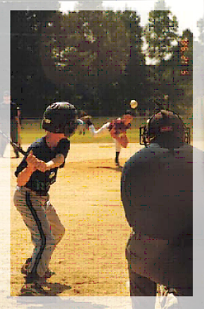

1. Land and Water Conservation Fund provides funding to preserve and develop outdoor recreation resources, including parks, trails and wildlife lands. Eligible projects include development, renovation, and land acquisitions for playgrounds, athletic fields, swimming pools, trails, picnic areas, campgrounds. This is a fifty percent grant. Maximum grant amount varies.
2. Boating Facilities Program. Funded by taxes on fuel used by motorboats, these funds are earmarked for “the acquisition and development of land for recreational boating purposes. Both shoreline and upland acquisition and development projects directly related to boating are eligible, including launch, ramps, transient moorage, and support facilities”. Local agencies and special purpose districts must provide 25 percent match for each project.
3. The Washington Wildlife and Recreation Program provides funding for a broad range of land protection and outdoor recreation, including park acquisition and development, habitat conservation, farmland preservation, and construction of outdoor recreation facilities. This is a fifty percent reimbursement grant. Maximum grant varies.
4. The Non highway and Off-road Vehicle Activities program NOVA provides funding to develop and manage recreation opportunities for such activities as cross-country skiing, hiking, horseback riding, mountain bicycling, hunting, fishing, sightseeing, motorcycling, and riding all-terrain and four-wheel drive vehicles. NOVA is funded by a portion of the fuel tax and by ORV permits fees. No match is required but it is strongly encouraged
5. Firearms Range Program. Funded by a portion of the cost of a concealed weapons permit, this program provides funds for the acquisition, development, and renovation of public and private nonprofit firearm range and archery training and practice facilities. This is a fifty percent reimbursement grant with a limit of $100,000.
6. The Recreational Trails Program provides funds to rehabilitate and maintain recreational trails and facilities that provide a backcountry experience. Project sponsors must match at least 20 percent of the grant award. All matching resources must be an integral and necessary part of the approved project.

**DNR Aquatic Lands Enhancement Account**

ALEA grants may be used for the acquisition, improvement, or protection of aquatic lands for public purposes. They also may be used to provide or improve public access to the waterfront. The ALEA program is targeted at re-establishing the natural, self-sustaining ecological functions of the waterfront, providing or restoring public access to the water, and increasing public awareness of aquatic lands as a finite natural resource and irreplaceable public heritage. ALEA is funded almost entirely by revenue generated by the Washington State Department of Natural Resources' management of state-owned aquatic lands.

**Federal Transportation Act – Enhancement Programs**

This program, administered by the Washington State Department of Transportation with recommendations from the North Central Regional Transportation Planning Organization, funds transportation systems “enhancement” including the following:

* Provision of Facilities for Bicycles and Pedestrians
* Acquisitions of Scenic Easement and Scenic or Historic Sites
* Scenic or Historic Highway Programs
* Landscaping and other Highway Programs
* Historic Preservation
* Rehabilitation and Operation of Historic Transportation Buildings
* Preservation of Abandon Railway Corridors
* Control and Removal of Outdoor Advertising
* Archaeological Planning and Research
* Mitigation of Water Pollution due to Highway Runoff

Projects must be primarily for transportation rather than recreation purposes, however such items as bicycle trail between Okanogan and Omak should be eligible, as should walking trails.

**Debt Financing**

Debt financing instruments such as general obligation bonds, revenue bonds, and commissioner bonds can be used to fund recreational improvements. They are more typically used for solid waste, sewer, and road improvements, however. General obligation bonds require voter approval. They also cannot be used for maintenance and operation.

Special Levies

Special levies are often proposed by taxing districts such as a Park and Recreation District. They must be voter approved and can be used for operation and maintenance (but only for a one year period). Other types of levies may or may not require voter approval, depending on limits imposed by state statute.

Donations

Many of the projects in the CIP list donations as a funding source. Donated labor and materials have been an integral part of existing outdoor recreation opportunities in the County. There are many benefits to working together to achieve the goals of this outdoor recreation plan, including a sense of pride and community ownership of recreation facilities.

Gift catalogs are an excellent way to fund items such as outdoor furniture, picnic tables, signs and other physical objects on which appreciation for the benefactors can be expressed. Donations can come from business interests as well as individuals. Volunteer time is always an invaluable contribution to recreation facilities, without which the parks and recreational opportunities would certainly be diminished.

User Fees

Although local fees area rarely significant enough to fund capital projects, user fees are often used to help cover operation and maintenance costs. Care must be taken, however, to make sure increases in user fees do not unintentionally deny County residents and visitors the ability to enjoy publicly funded facilities. User fees such as snowmobile licensing fees[3], sno-park permits2 and trail pass sales are used to operate and maintain the extensive groomed snowmobile trail system, plowing of Sno-parks and grooming of the Nordic trails in the Methow Valley and on Bear Mt. at the Loup Loup.

Cooperative or Joint Use Agreements

Agreements are more a way to reduce expenses than a source of funds. Many communities have found that one agency is not able to take on a commitment to new or expanded facilities alone. In many cases, inter-local agreements have been established between neighboring cities, counties, school districts, and other public entities to lay the ground work for cooperative use, staffing, and maintenance.

The County, cities and the school districts are provided the ability to enter into agreements that serve legitimate public purposes, although the County cannot "give" public funds to an entity without a contract specifying what services are being provided by the entity. Doing so would be a violation of the state's constitution (Article 8, Section 7).

Although subjects covered by additional inter-local agreements are limited only by the imagination, care must be taken to make sure they are mutually beneficial to all parties involved. In most cases, inter-local agreements are set up to save public funds by avoiding duplicate efforts and the construction of redundant facilities. The County, cities and school districts and any other interested parties could begin exploring opportunities to establish additional or expanded inter-local agreements by considering the questions below.

1. Currently, who is responsible for taking care of which facilities?
2. Currently, who is using what facilities?
3. Who is most capable of taking care of the various existing facilities, both from a practical and financial standpoint?
4. What percentage of park users live inside City limits or outside of the County? What, if anything, might cause this percentage to go up or down in the future?
5. What agreements are currently in place? How could they be improved?
6. Would establishing long term leases or even transferring title to property or portions of property be in the interest of the parties involved?

Real Estate Excise Tax (REET)

In 1994, the County began collecting a one-quarter of one percent Real Estate Excise Tax. This is above and beyond the real estate tax collected by the State of Washington. The tax is imposed each time real property changes hands within the County. For obvious reasons, the amount received by the County is proportional to level of real estate activity in the area.

Proceeds from the Real Estate Excise Tax can be used for many things. The state statute gives some examples, focusing on improvements that can also be funded through a Local Improvement District (LID): streets, parks, sewers, water mains, swimming pools, and gymnasiums.

The REET cannot be used for items such as fire engines and computers. Projects must be things than can be done to or on a parcel of property. Arguably, the REET also cannot be used for the repair and rehabilitation of existing facilities or the acquisition of park land, unless the County finds itself planning under the Growth Management Act at some point in the future.

Lodging Excise Tax

Also called the Hotel/Motel Tax, the Lodging Excise Tax is a 2% charge applied at the time hotel rooms, trailer sites, and other accommodations are furnished to visitors. Compared to the REET (above), the purposes for which this tax can be used are severely limited. The funds are typically used for promotion of the area in various publications. Particularly in more populated areas where larger amounts are generated, the tax is also used for the construction of convention centers, stadiums, and performing art centers. The Agriplex was funded in part by dedicating a portion of this tax to repay debt incurred to construct the facility.

General Fund

With the exception of the County Fairgrounds, most outdoor recreation improvements in the County have been predominantly funded by cities, state and federal grants, state and federal agencies and donations of dollars, land, labor and materials from the private and non-profit sectors.

Use of the general fund for recreation improvements is perfectly appropriate, subject to the approval of the County Commissioners. It is hoped that this plan will be a useful tool that can be used to guide general fund decision regarding outdoor recreation improvements.

It goes without saying that the County has many obligations to fill, many of them mandated by either state or federal agencies. The fact that outdoor recreation improvements are not mandated may help explain why they tend to get little of the budget pie. Still, implementation of this plan will likely require the County to consider using the General Fund to pay for lower cost improvements and to help meet match requirements of state funding agencies.

Budget Line Item

A strategy used for larger projects with significant economic impact to the County is to work with state and federal elected representatives and senators on inclusion of project funding as a line item in the state or federal budget.

**Bibliography**

Federal Energy Regulatory Commission, Office of Energy Projects, Revised List of Comprehensive Plans (Statewide Comprehensive Recreation Plan SCORP Inventory Appendix B), October 2003

Methow Valley Sports Trails Association (MVSTA), information regarding effort to build ski and bicycle trails and growth information, map information.

Okanogan County, Okanogan County Comprehensive Parks and Recreation Element. Okanogan County Comprehensive Plan, April 12, 1993

Okanogan County, Okanogan County Department of Public Works, Paths and Trails Committee, web based survey and results from focus groups and a survey conducted in 1999; Snowmobile park maps; along with many sources of information

Okanogan County Fairgrounds, The Agri-Plex and Annex Facility, 2001. <<http://www.okanogancountyfair.org/agriplex.html>> Agri-plex and Annex facility information and map.

Okanogan County, Washington. Okanogan County demographic information <<http://www.okanogancounty.org/DEMO.HTM>>

RJR and Associates, Visitor Profile and Preferences Study. December 1999

United States Forest Service, Okanogan and Wenatchee National Forest. information regarding trailheads, campsites, and other attractions.

United States, Bureau of Census. April 2010 Census, State of Washington, Okanogan County. Population, age distribution, racial breakdown, and household information.

Washington State 2007 Data Book, Office of Financial Management, Forecasting Division. Population projections

Washington State Labor market information, Access Washington. Economic and workforce information <<http://www.wa.gov/esd/Imea/>>

Washington State Parks, Okanogan County park information

Washington State Department of Natural Resources (DNR), park and recreational facilities

MVSTA 2005 Economic Analysis

1. Non-market benefits have value as indicated by measures of consumer surplus applied through travel-cost models and other methods; however, their accounting is applied here only in terms of estimates of active and passive recreation use values. Active and passive use non-market valuation studies require significant time and resources, and are outside the scope of this study.
2. Appropriately addressing expenditures related to trail use/visits requires inclusion of all trail users (local, non-local, resident) within the analysis; thus, all are “visitors”. Attribution of “visits” or “per trip” terms related to discussion of residents takes into account the spectrum of the resident population, which consists of a substantial number of second home owners, rental property owners, landowners who camp on their lands, and others with residential arrangements in Methow Valley. This framework simplifies the discussion and adheres to convention for recreation resource studies.
3. - fees imposed by the State which are collected into a fund for granting back to local organizations for M&O cost as well as capital projects.